�7111i£�
\...
r'
1
I
t �-
1·
:�..,.,,. ·-·Y

II
-

II

. L...J

• ••
I

' '
---

..-""'

I
--d
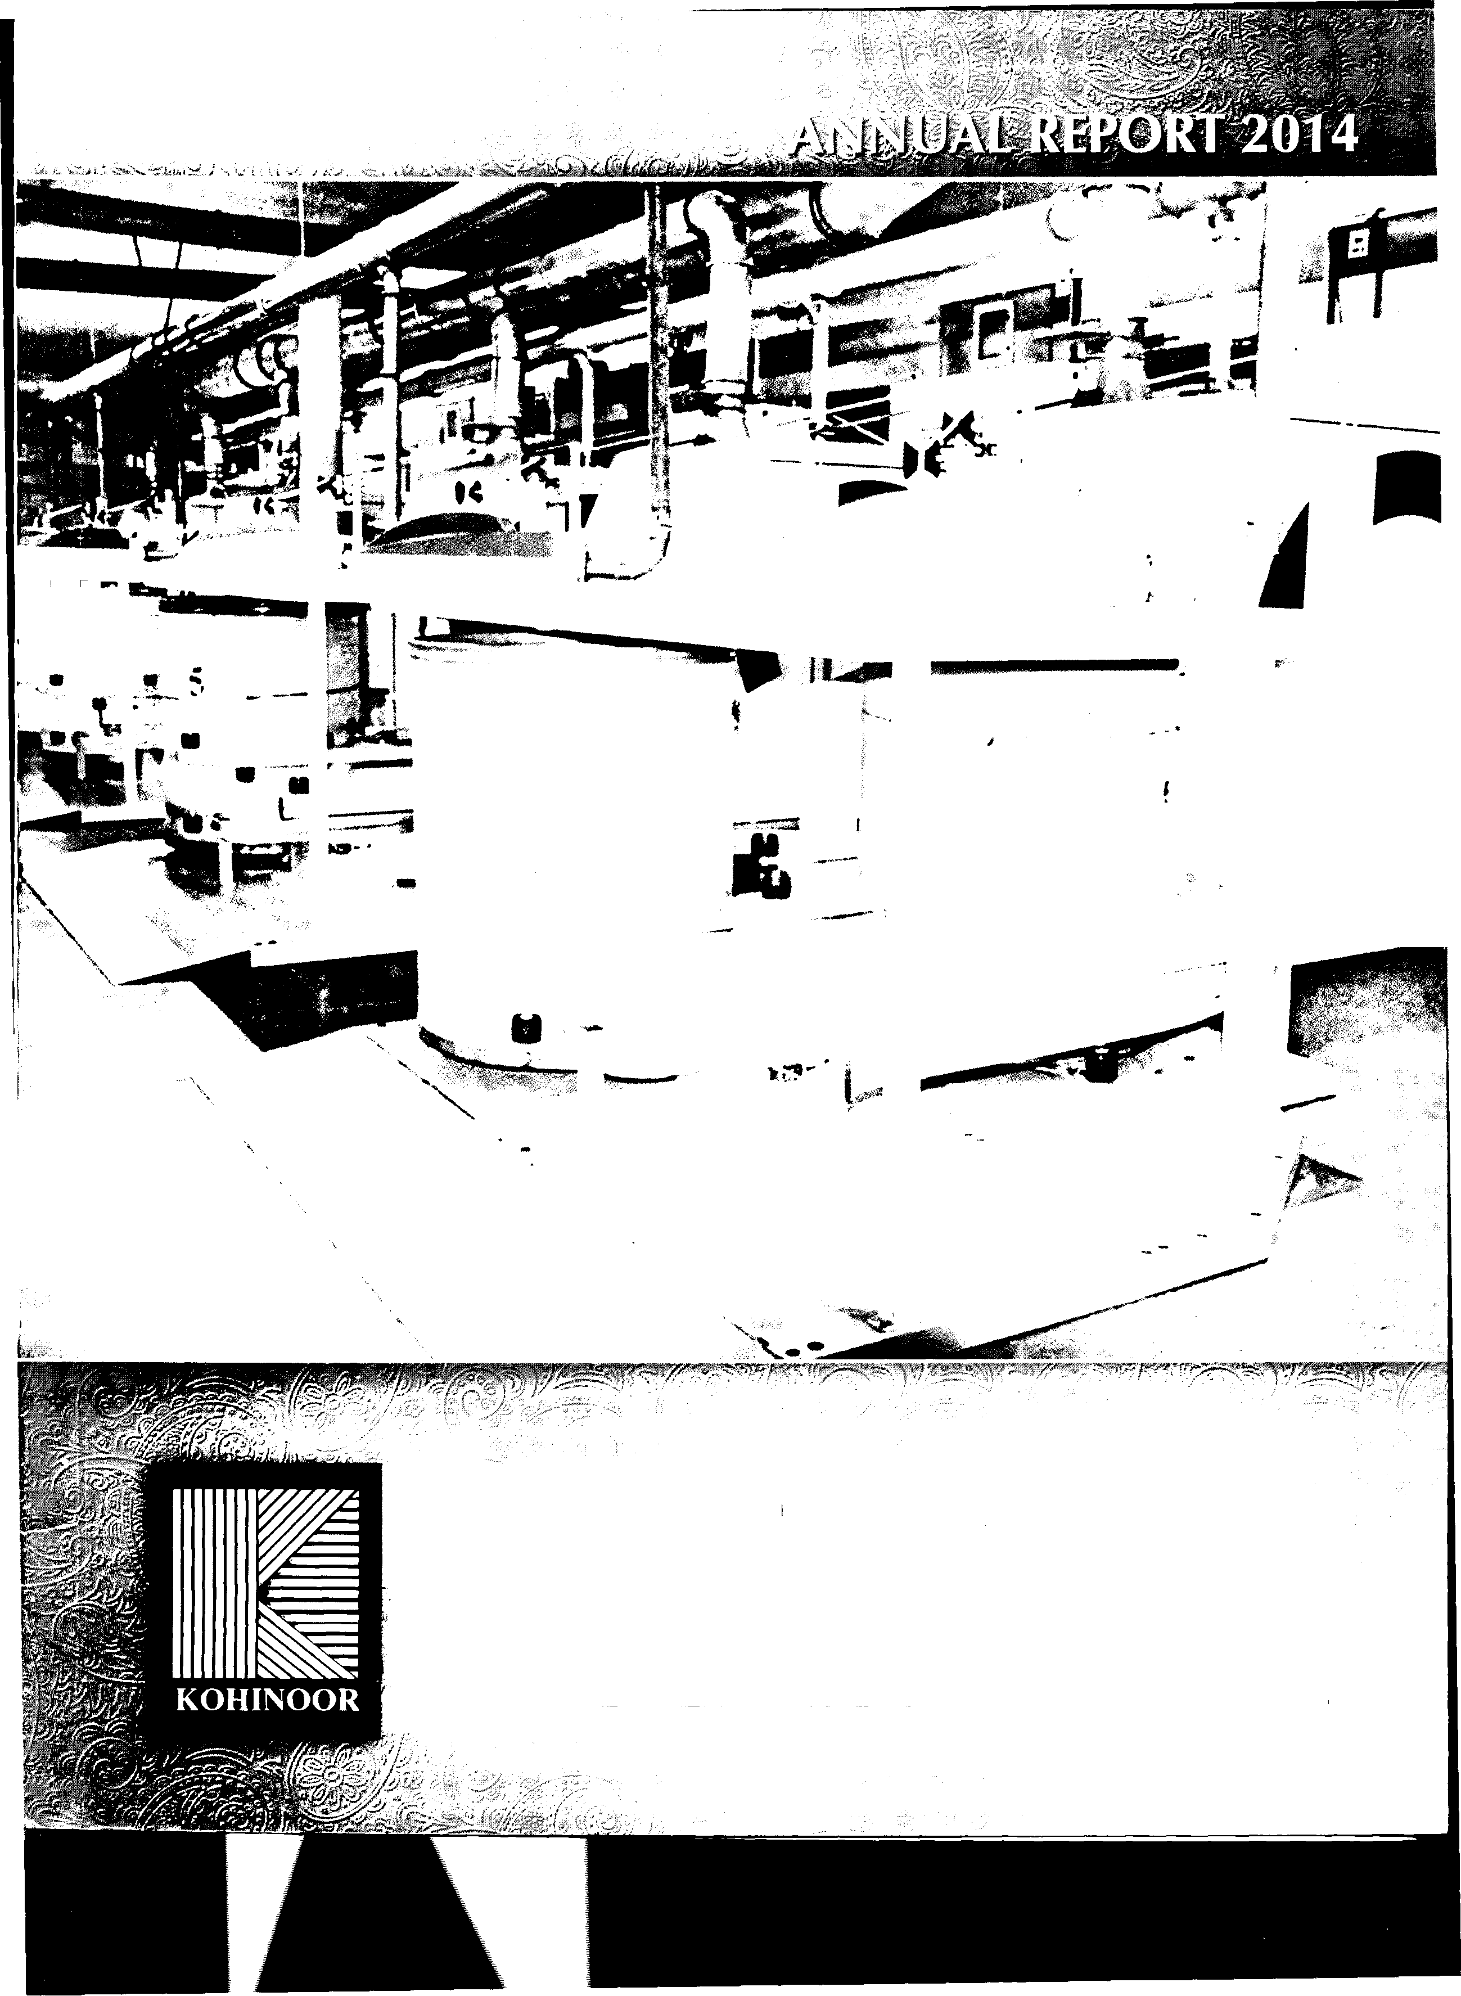

{Kohinoor
,,�p_i�ning Mills limited
1
·,,: �·. r , a{tnY:,:J;A:f::: ;:> /-, . . . .
Company Information |  | 02
Directors' Profile |  | 03
Vision |  | 04
Mission |  | 04
Notice of Annual General Meeting Alongwith Relevant Statements |  | 05
SWOT Analysis |  | 07
Directors' Report |  | 08
Statement of Value Addition and Distribution |  | 10
Financial Highlights of Last Six Years |  | 12
Horizontal Analysis |  | 13
Vertical Analysis |  | 14
Graphical Presentation of Financial Highlights |  | 15
Statement of Compliance with the Code of Corporate Governance |  | 16
Review Report To The Members on Statement of Compliance with Best Practices of | Code of Corporate Governance | 18
Auditors' Report To The Members |  | 19
Balance Sheet |  | 20
Profit and Loss Account |  | 22
Statement of Comprehensive Income |  | 23
Cash Flow Statement |  | 24
Statement of Changes In equity |  | 25
Notes To The Financial Statements |  | 26
Pattern of Holding of Shares and Disclosures as Per CCG Requirement |  | 50
Form of Proxy |  | 53

c��..
o··�.

1.£,iPA\
,n
i.n�•'V-,

1IJ�
1;-·F;�,y!.n._,1.£A. -� f�

ll�
.I

!i •

BOARD OF DIRECTOR Mr. Mohammad Naveed Khawaja Mohammad Jawed Khawaja Mohammad Jahangir Khawaja Mohammad Tanveer Khawaja Mohammad Kaleem Khawaja Mohammad Nadeem Mr. Mohammad Hamza Yousaf Mr. Mohammad Tariq Sufi

AUDIT COMMITTEE
Khawaja Mohammad Jahangir Khawaja Mohammad Kaleem Khawaja Mohammad Nadeem

HR & REMUNERATION COMMITTEE
Khawaja Mohammad Kaleem Khawaja Mohammad Nadeem Mr. Mohammad Naveed

CORPORATE SECRETARY Mr. Muhammad Jahangir Khan jahangir@chakwalgroup.com.pk

CHIEF FINANCIAL OFFICER
Mr. Muhammad Saeed Zafar

BANKERS
Habib Metro Bank Limited MCB Bank Limited National Bank of Pakistan
Standard Chartered Bank (Pakistan)Limited
Allied Bank of Pakistan Meezan Bank Limited Askari Bank Limited

AUDITOR
Aslam Malik & Co. Chartered Accountants Suite# 18-19,lst Floor, Central Plaza, Civic Centre,
New Garden Town, Lahore. Pakistan

CORPORATE & REGISTERED OFFICE
7/1-E-3 Main Boulevard Gulberg 111, Lahore
Tel: (042) 35717510
Fax: (042)35755760

SHARE REGISTRARS
Corp link (Pvt) Limited
Wings Arcade, 1-K, Commercial, Model Town, Lahore
Tel : (042) 35839182
Fax : (042) 35869037

MILLS
Unit I &II
Aminabad, Chakwal
Tel : (0543) 644254 - 644281

Unit Ill
Yousaf Nagar, Bhoun Road, Chakwal.
Tel: (0543)452070-71

2

(Chief Executive) (Director) (Director) (Director) (Director) (Director) (Director)
,n
(Independent Director)

(Chairman) (Member) (Member)

(Chairman) (Member) (Member)

BA (LLB), MBA, DTL, ACIS

M.B.A

Khawaja Mohammad Jawed:

Khawaja Muhammad Javed, a legendary businessman, is the Chairman I executive director of the Company and is widely respected in the business community due to his wisdom and vision. He has more than
40 years' experience in textile spinning, weaving, cement, polyester, and banking sector. His role in the company is mainly to give strategic direction and take policy decision.

Khawaja Mohammad Jahangir:

He is serving as a non-executive director on the Board of the Company and has more than 35 years' diversified experience in business and industry especially in Fiber and Textile Spinning. Also, he holds the slot of Chief Executive Officer in Chakwal Spinning Mills Limited (a sister concern of the company). He is the Chairman of Audit Committee of the Company.

Khawaja Mohammad Tanveer:

Serving as an non-executive director on the Board of the Company, his prime responsibility is to look after the administrative matters arising in plant sites of the Company. With more than
25 years' rich business and industry experience, he is also a renowned participant in many social and welfare activities.
Khawaja Mohammad Kaleem:

Khawaja Kaleem is serving in the capacity of non-executive director on the Board of the Company with more than 35 years' diversified experience in various business and industry sectors including Textile Spinning, Cement & Fiber industries. He is energetically involved in the implementation of the company policies and monitors the performance of the all group companies. He is also the Chairman of HR and Remuneration Committee.

Khawaja Mohammad Nadeem:

Mr. Nadeem completed his business graduation from USA and is on the board of the company as a non• executive director and a member of Audit, HR and Human Resource Committees of the Company. With more than a decade experience in the lines of spinning and weaving textile sectors, he is mainly involved in routine business operations including production, marketing and finance activities of Yousaf Weaving Mills Limited ( a sister concern of the company) where he hold the position of Chief Executive officer.

Mr. Mohammad Naveed:

Mr. Naveed did his Graduations from the reputed institution of USA. With vast business experience in Fibers, Textile Spinning, Cement and banking sectors, he is leading the company as chief Executive Officer and executive director since 2004. He is also a member of HR and Remuneration Committee of the Company.

3
Mr. Mohammad Hamza Yousaf:

He is serving as a non-executive director and been with the company since 2009. Having done his Masters in Marketing and Strategy from United Kingdom and with extra skills of negotiation, he markets the product well. He has been delegated the responsibilities of supervision of all matters concerning to Unit-2 of the Company.

Mr. Mohammad Hamza Yousaf, has also completed directors training program during the year through Institute of Chartered Accountants of Pakistan duly approved by the SECP as required in terms of code of corporate Governance.

Mr. Mohammad Tariq Sufi

Mr. Sufi is an independent director of the company and recently elected in the EOGM held on September 10, 2014 in accordance with the requirements of code of corporate Governance. He has excellent experience in textile spinning particularly in the area of store
I inventory management. Therefore,
we have high expectations from him and expect him to become an intangible asset of the company in near future

-------------------- --- -- -- -- -- -- -- -- ---·-- --

Kohinoor Spinning Mills Limited
Annual Report
2014

NOTICE OF ANNUAL GENERAL MEETING

-�-

Notice is hereby given that the 42nd Annual General Meeting of KOHINOOR SPINNING MILLS LIMITED will be held on Friday, October 31, 2014 at 10:00 a.m. at 31-F Main Market Gulberg II, Lahore to deal with the following matters:-

ORDINARY BUSINESS:

1. To confirm the minutes of EOGM held on September 10, 2014.

2. To receive and adopt the audited accounts of the Company for the year ended June 30, 2014 together with the reports of directors and auditors thereon.

3. To consider and approve final cash dividend of 5% (Re. 0.25 per ordinary share of Rs. 5/ each) held by the existing shareholders as recommended by the board of directors. This is in addition to the interim cash dividend of 10% (Re.0.50 per ordinary share of Rs. 5/- each) already paid to the shareholders during the year.

4. To reappoint auditors for the year ending June 30, 2015 and to fix their remuneration.

SPECIAL BUSINESS:

1. To consider and approve the remuneration of a Director of the company.

2. To transact any other business which may be brought forward with the permission of the Chair.

Statement u/s 160 along with information u/s 218 of the companies ordinance, 1984 is annexed to the notice of the meeting sent to the shareholders.

BY ORDER OF THE BOARD

NOTES:

1 . A member entitled to attend the meeting may appoint another member as his/her proxy to attend the meeting of him/her behalf. Proxies in order to be effective must be received by the Company not later than 48 hours before the meeting.

2. The beneficial owner of the shares of the company in the central depository system of the CDC or his/her proxy entitled to attend this meeting shall produce his/her original CNIC or passport to prove the identity. CDC Account Holders will further have to follow the guidelines as laid down in Circular No. 1 dated 26 January 2000 issued by the Securities and Exchange Commission of Pakistan.

3. Transfer received in order by the close of business hours on October 24, 2014 will be treated in time. The same or any change in address, if any, alongside valid copy of CNIC for filing annual return of company be sent to our share registrar M/s Corp link (Pvt) Limited, Wings Arcade, 1-K, Commercial, Model Town, Lahore. Tel. 042-3583 9182.

4. It is also informed that pursuant to the Finance Act, 2014, effective from July 1, 2014, the rate of withholding tax in terms of section 150 of the ITO, 2001 has been segregated
@ 10% for filer and @ 15% for non filer of income tax returns, so necessary evidence, NTN etc is also advised to be provided timely.

5. In terms of SECP,s SRO 787(1 )/2014, members can now receive audited financial statements alongside notice of AGM electronically through email. Therefore members (physical or CDC shareholders) who are interested in receiving the same are required to send their email addresses and consent for electronic transmission to share registrar of the company or directly to their broker(participant)/CDC investor account services, as the case may be.
Lahore:
October 10, 2014

BOOK CLOSURE

MUHAMMAD JAHANGIR KHAN
Company Secretary/General Manager (Legal)

STATEMENT UNDER SECTION 160 OF THE COMPANIES ORDINANCE, 1984

The statement sets out the material facts concerning the special business to be transacted at the 42nd Annual General Meeting of the Company to be held on October 31, 2014.

The Member's Register will remain closed from October 25, 2014 to
October 31, 2014 (both days inclusive).
Approval of the shareholders will be sought for the remuneration payable to the a Director Mr. Mohammad Hamza Yousaf. For this purpose, it is intended to propose that the following resolution be passed as a Special Resolution.
"RESOLVED THAT the company hereby authorizes the payment as remuneration to a Director Mr. Mohammad Hamza Yousaf not exceeding in aggregate of Rupees 150,000/- per month inclusive of house rent allowance and exclusive of utilities and other perquisites and benefits w.e.f July 01, 2014 to which he is entitled under their terms of employment".

The Director may be considered interested in this special business to the extent of remuneration payable to him.

5

KOHINOOR
KOHINOOR SPINNING MILLS LIMITED

CORPORATE & SHARES DEPARTMENT
7/1, E-3, Main Boulevard Gulberg 111, Lahore
042 35757108

NOTICE UNDER SECTION 218 OF THE COMPANIES ORDINANCE, 1984

TO ALL MEMBERS OF THE COMPANY

In terms of section 218 of the Companies Ordinance, 1984 the members of the company are informed that the Board of Directors in their meeting held on October 10, 2014 has approved remuneration, perquisites and allowances of Mr. Mohammad Hamza Yousaf, working Director of the company as per following:

Remuneration Gross aggregate monthly salary not exceeding Rs. 150,000/• (rupees one hundred fifty thousand only). This will exclusive of other allowances as per company policy like medical, conveyance, gratuity etc and take effect from July 1, 2014

Mr. Muhammad Hamza Yousaf, being director and shareholder of the company have interest to the extent of remuneration and other benefits to which he is entitled.

For and on behalf of Kohinoor Spinning Mills Limited

Lahore:
October 10, 2014
Muhammad Jahangir Khan
Company Secretary/General Manager (legal)

Registered Office: Kashana-e-Yousaf Khawaja Street, Chakwal. Tel: 0543-540850, 540950
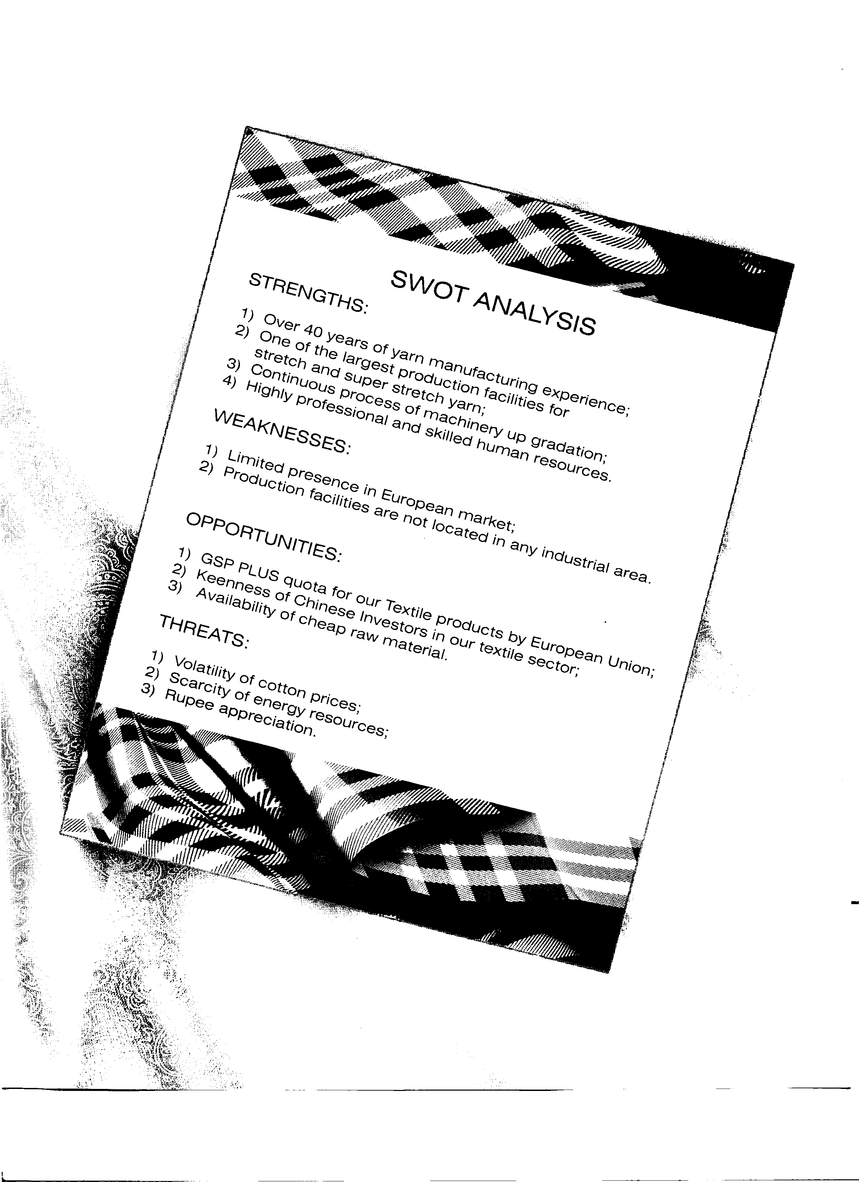

·.,
'3

The directors of your Company have fe pleasure in presenting to you the annual results for the year ended 30 June 2014.

Financial Performance:
Your Company has earned after tax profit of Rs. 120.953 million as compared to after tax profit of Rs. 265.524 million for the corresponding last year. The slide in profitability is attributed to the non-responsive yarn market towards higher cotton prices, appreciation of Pak rupee against US Dollar and more power outages as compared to the corresponding last year.

Sales have increased from Rs. 6,230 million in 2013 to Rs. 6,823 million in the current year (an increase of 9.52%). Similarly, gross profit has registered 2.64% reduction as compared to the corresponding last year (i.e. from 13.59% in 2013 to 10.95% in 2014).

Keeping with this trend, net profit has reduced from 4.26% in 2013 to 1.77% in 2014 (a decrease of 2.49%).

Earnings Per Share (EPS):
The Basic earnings per share (EPS) of the Company for the year
2014 remained at Re. 0.93 (2013: Rs. 2.04). There is no dilution effect on the basic earnings per share of the Company as the Company has no such commitment.

Projects:
Your Company believes in production efficiencies. This is the reason that we invest heavily in our plant and machinery. During the year under review, our main projects were as follows:

a) New Blow Room Lines and Cards For Unit-1
Our unit-1 was being used for manufacturing of PP and PV yarn. This year, we have decided to shift it to Cotton yarn. For this purpose, we have imported machinery worth Euro 1.563 million. Currently, this machinery is under installation and soon we would be able to start commercial production. The advantages of this up-gradation are as follows:

1) Increase in production capacity;
2) Higher anticipated yarn yield;
3) Reduction in salaries;
4) Better yarn rates due to improved yarn quality;
5) Export sale by Unit-1

b) Diesel Generators
The availability of energy is a main concern for us these days. At our Unit-3, we had electricity being supplied by WAPDA and electricity being generated by our own gas fired captive power plant. However, these two sources were unable to run our unit-
3 for 24/7. To mitigate economic losses due to mill shut down, we have purchased diesel generators (each having 1 250 KVA rated capacity). In case of WAPDA shut down and low gas pressure, we run diesel generators.

Directors' Sub-Ordinated Loan:
The directors of your Company have always shown readiness to step in when your Company needs funds. The purpose of this strategy is to avoid un-necessary delays in execution of proposed projects as financial strength of our Company mainly depends on operational efficiencies of our manufacturing facilities. This year, we have contributed Rs. 303 million to finance cash flow needs of the Company.

This not only shows our commitment towards our Company but also towards shareholders of our Company who stood by us through thick and thin.

Subsequently, the directors of the Company have sought Securities and Exchange Commission of Pakistan (SECP)'s approval for conversion of this loan into equity.

Contribution To National Exchequer and Economy:
During the year, your Company has contributed an amount of Rs. 175 million towards national exchequer by way of sales tax and income tax. The Company is also acting as withholding agent for FBR. The Company has also contributed through earnings of precious foreign exchange amounting to Rs. 2,598 million. Also, we are the employer of more than 2,500 persons.

Major Risks and Risk Management:
The Board of Directors has overall responsibility for the establishment and oversight of Company's risk management framework. Following is the detail of major risks and our policies to mitigate these risks:

a) Fluctuation In Cotton Prices
Cotton is our major raw material. Fluctuation in cotton prices have always been a major risk for a spinning unit. Cotton prices depend on many factors like demand and supply, prices in international market, flood situation in the country, hoarding etc. Though ginned cotton is available throughout the year, best cotton is available in cotton season only. The Company mitigates this risk by procuring cotton when market takes a dip. Also, we spread our procurement throughout the year in a way that maximum cotton is procured in peak season.

b) Yarn Demand and Supply
At our Unit-3, we manufacture stretch and super stretch yarn. This is value-added yarn with better margins. However, demand of this yarn is seasonal. It is very difficult to dispose of this yarn in off-peak season. We mitigate this risk by reducing our stretch and super stretch yarn production.

c) Exchange Risk
This year, Pak rupee appreciated against foreign currencies. This trend was unprecedented, as we have always seen weakening of Pak rupee. We mitigate this risk by diverting our export sale portion in local market. Also, we do not heavily book export order.

d) Energy Non-Availability:
Electricity and gas load shedding is one of the major crisis. This crisis appears to have no end in sight. With winter just approaching, we are awaiting new gas load shedding schedule by SNGPL (currently, we are already facing at least sixteen hours gas shut down per day). Also, we are facing at least eight hours electricity shut down per day. Even though electricity prices have almost doubled, electricity supply is stagnant. At our Unit-3, we have purchased diesel generators to mitigate this risk.

e) Interest Rate Risk:
Though State Bank of Pakistan (SBP) has kept discount rate at
10% continuously for quite sometimes, any upward shift in interest rate would affect our profitability. Economic indicators are monitored to better understand the interest rate trend.
8

Textile sector is the backbone of our economy, accounting for 8 percent of GDP with significant potential for growth. It has the most intensive backward and forward linkages within the wider economic
Audit Committee

Name of Directors

No of Board Meetings
chain compared to any other sector, linking agriculture through industry |  |  | held | attended
to exports. Cotton contributed 24 percent of the industrial sector's
value-added output, employing 40 per cent of industrial sector's work | 1. | Khawaja Mohammad Jahangir | 5 | 5
force, using 40 percent of bank credit given to the industrial sector | 2. | Khawaja Mohammad Kaleem | 5 | 5
and accounting for nearly 55 percent of Pakistan's exports. In addition, | 3. | Khawaja Mohammad Nadeem | 5 | 5
this sector provides a livelihood to more than 1 O million farming

families.
HR & REMUNERATION COMMITTEE

Spinning industry, in Pakistan, has many challenges to face. Despite difficult situation ahead due to uncertain cotton market and power shortages, we are hopeful that your Company would continue its journey of profitability. The management of your Company continues to make best efforts, through strategy of expanding and diversifying product range and targeting new and growing markets.
Salient Aspects of Company's Control and Reporting System. The Company Complies with all the requirements of the Code of
Corporate Governance as contained in the listing regulations of the
Stock Exchanges. To fulfill this role, the Board is responsible to implement overall corporate governance in the company including approval of the strategic direction as recommended by the Management, approving and monitoring capital expenditure. appointing, removing and creating succession policies for the senior management, establishing and monitoring the achievement of management's goals and ensuring the integrity of internal control and Management Information System. It is also responsible for approving and monitoring financial and other reporting. The Board has delegated responsibility for operation and administration of the company to the Chief Executive/ Managing Director. Responsibilities are delineated by formal authority delegations. The Board has constituted the following committees which work under the guidance of Board of Directors -

a) Audit Committee
b) Human Resource Committee

Independent Director. The Board welcomed Mr. Mohammad Tariq Sufi who has been elected in EOGM held on September 10, 2014 as independent director.

Attendance of Meetings. During the year under review, attendance by each director is given below -

a) Board of Directors
1. Khawaja Mohammad Kaleem 5 5
2. Khawaja Mohammad Nadeem 5 5
3. Mr. Mohammad Naveed 5 5

All meetings of the Board met minimum quorum prescribed by the Code of Corporate Governance and also attended by the Chief Financial Officer and the Company Secretary, However the Board granted leave of absence to the directors who could not attend the meetings due to their pre-occupation.

Pattern of Share-Holding
The pattern of shareholding as on 30-06-2014 and its disclosure as per requirement of Code of Corporate Governance is annexed with this report;

Auditors
The present auditors Messrs. Aslam Malik & Co., Chartered Accountants will stand retired at the conclusion of the 41 st Annual General Meeting. However, they have expressed their willingness for re-appointment. They have also been recommended by the as external Auditors till conclusion of 42nd Annual General Meeting on existing terms and conditions.

Dividend
The Directors are pleased to recommend a final cash dividend of Re. 0.25 per share of Rs.5/- each. This is in addition to an interim cash dividend of Re. 0.5 per share already approved by the Board of Directors and paid to the shareholders. The total dividend to be approved by the shareholders at the Annual General Meeting on 31st October 2014 will be Re. 0.75 per share i.e. 15% for the year ended
30th June 2014. However, Directors of the Company have decided to forego their right to receive dividend.

Acknowledgement:
In the end, the Board expresses our deep sense of gratitude for the services, loyalty and efforts being continuously rendered by the employees of the Company. Also, credit must go to our shareholders
Name of Directors
No of Board Meetings
who have always shown their confidence and faith in the Company.
1. | Khawaja Mohammad Javed | held  4 | attended  4 |  |  | For and on behalf of the Board
2. | Khawaja Mohammad Jahangir | 4 | 3
3. | Khawaja Mohammad Tanveer | 4 | 4
4. | Khawaja Mohammad Kaleem | 4 | 3
5. | Khawaja Mohammad Nadeem | 4 | 4
6. | Khawaja Mohammad Naveed | 4 | 4 |  | Lahore: | Mohammad Naveed
7. | Mr. Mohammad Hamza Yousaf | 4 | 4 |  | 10 October 2014 | Chief Executive Officer
8. | Mr. Mohammad Tariq Sufi | 4 | 0
 |  |  |  | g
 | , ,,· |  |  |  | .�1,,i- ·.,'·
 | '!'" |  |  |  | - f:',. itl-il/:i��'.j,.;.

.\.�.'J
,.

(
',.,""

. /·.
l···.,···'
,·
< ·{
 | 2 4  (Rupees) | %age 2013 (Rupees) | % age
Gross Sales Revenue | 6,929, 734,454 | 6,255,538,4 7 4
Other operating Income | 291,750 | 2,870,017
 | 6,930,026,204 | 6,258,408,491
Less:
Material and factory Cost | 5,523,773,833 | 4,860,602,310
Administrative and other expenses | 71,200,935 | 68,843,477
Distribution | 152, 142,405 | 135,385,672
Value Added | 1, 182,909,030 | 100% 1, 193,577,032 | 100%

Wealth Distributed

To Employees
Salaries, wages and benefits | 526, 782, 152 | 45% | 490,334,308 | 41%
To Govt.
Tax | 174,970,675 | 15% | 92,251,712 | 8%
Workers' Profit participation fund | 9,956,979 | 1% | 16,299,686 | 1%

To Providers' of Capital
Dividend to share holders

5,432,915 0%

1,048,4 71 0%

Finance Cost

To Provide for Maintenance and Expansion of Assets
259,814,814
22%
238,489,249
20%
Depreciation | 90,431,738 | 8% | 90,678, 122 | 8%
Profit Retained | 115,519,757 | 10% | 264,4 75,484 | 22%
 | 1,182,909,030 |  | 1,193,577,032

10
.�.· .·;.
•

,J. ..l
I
I ' �.

'l \,

17.41%
2014

44.53%

• To Employees

� To Govt.

To Providers' of Capital

22.42%

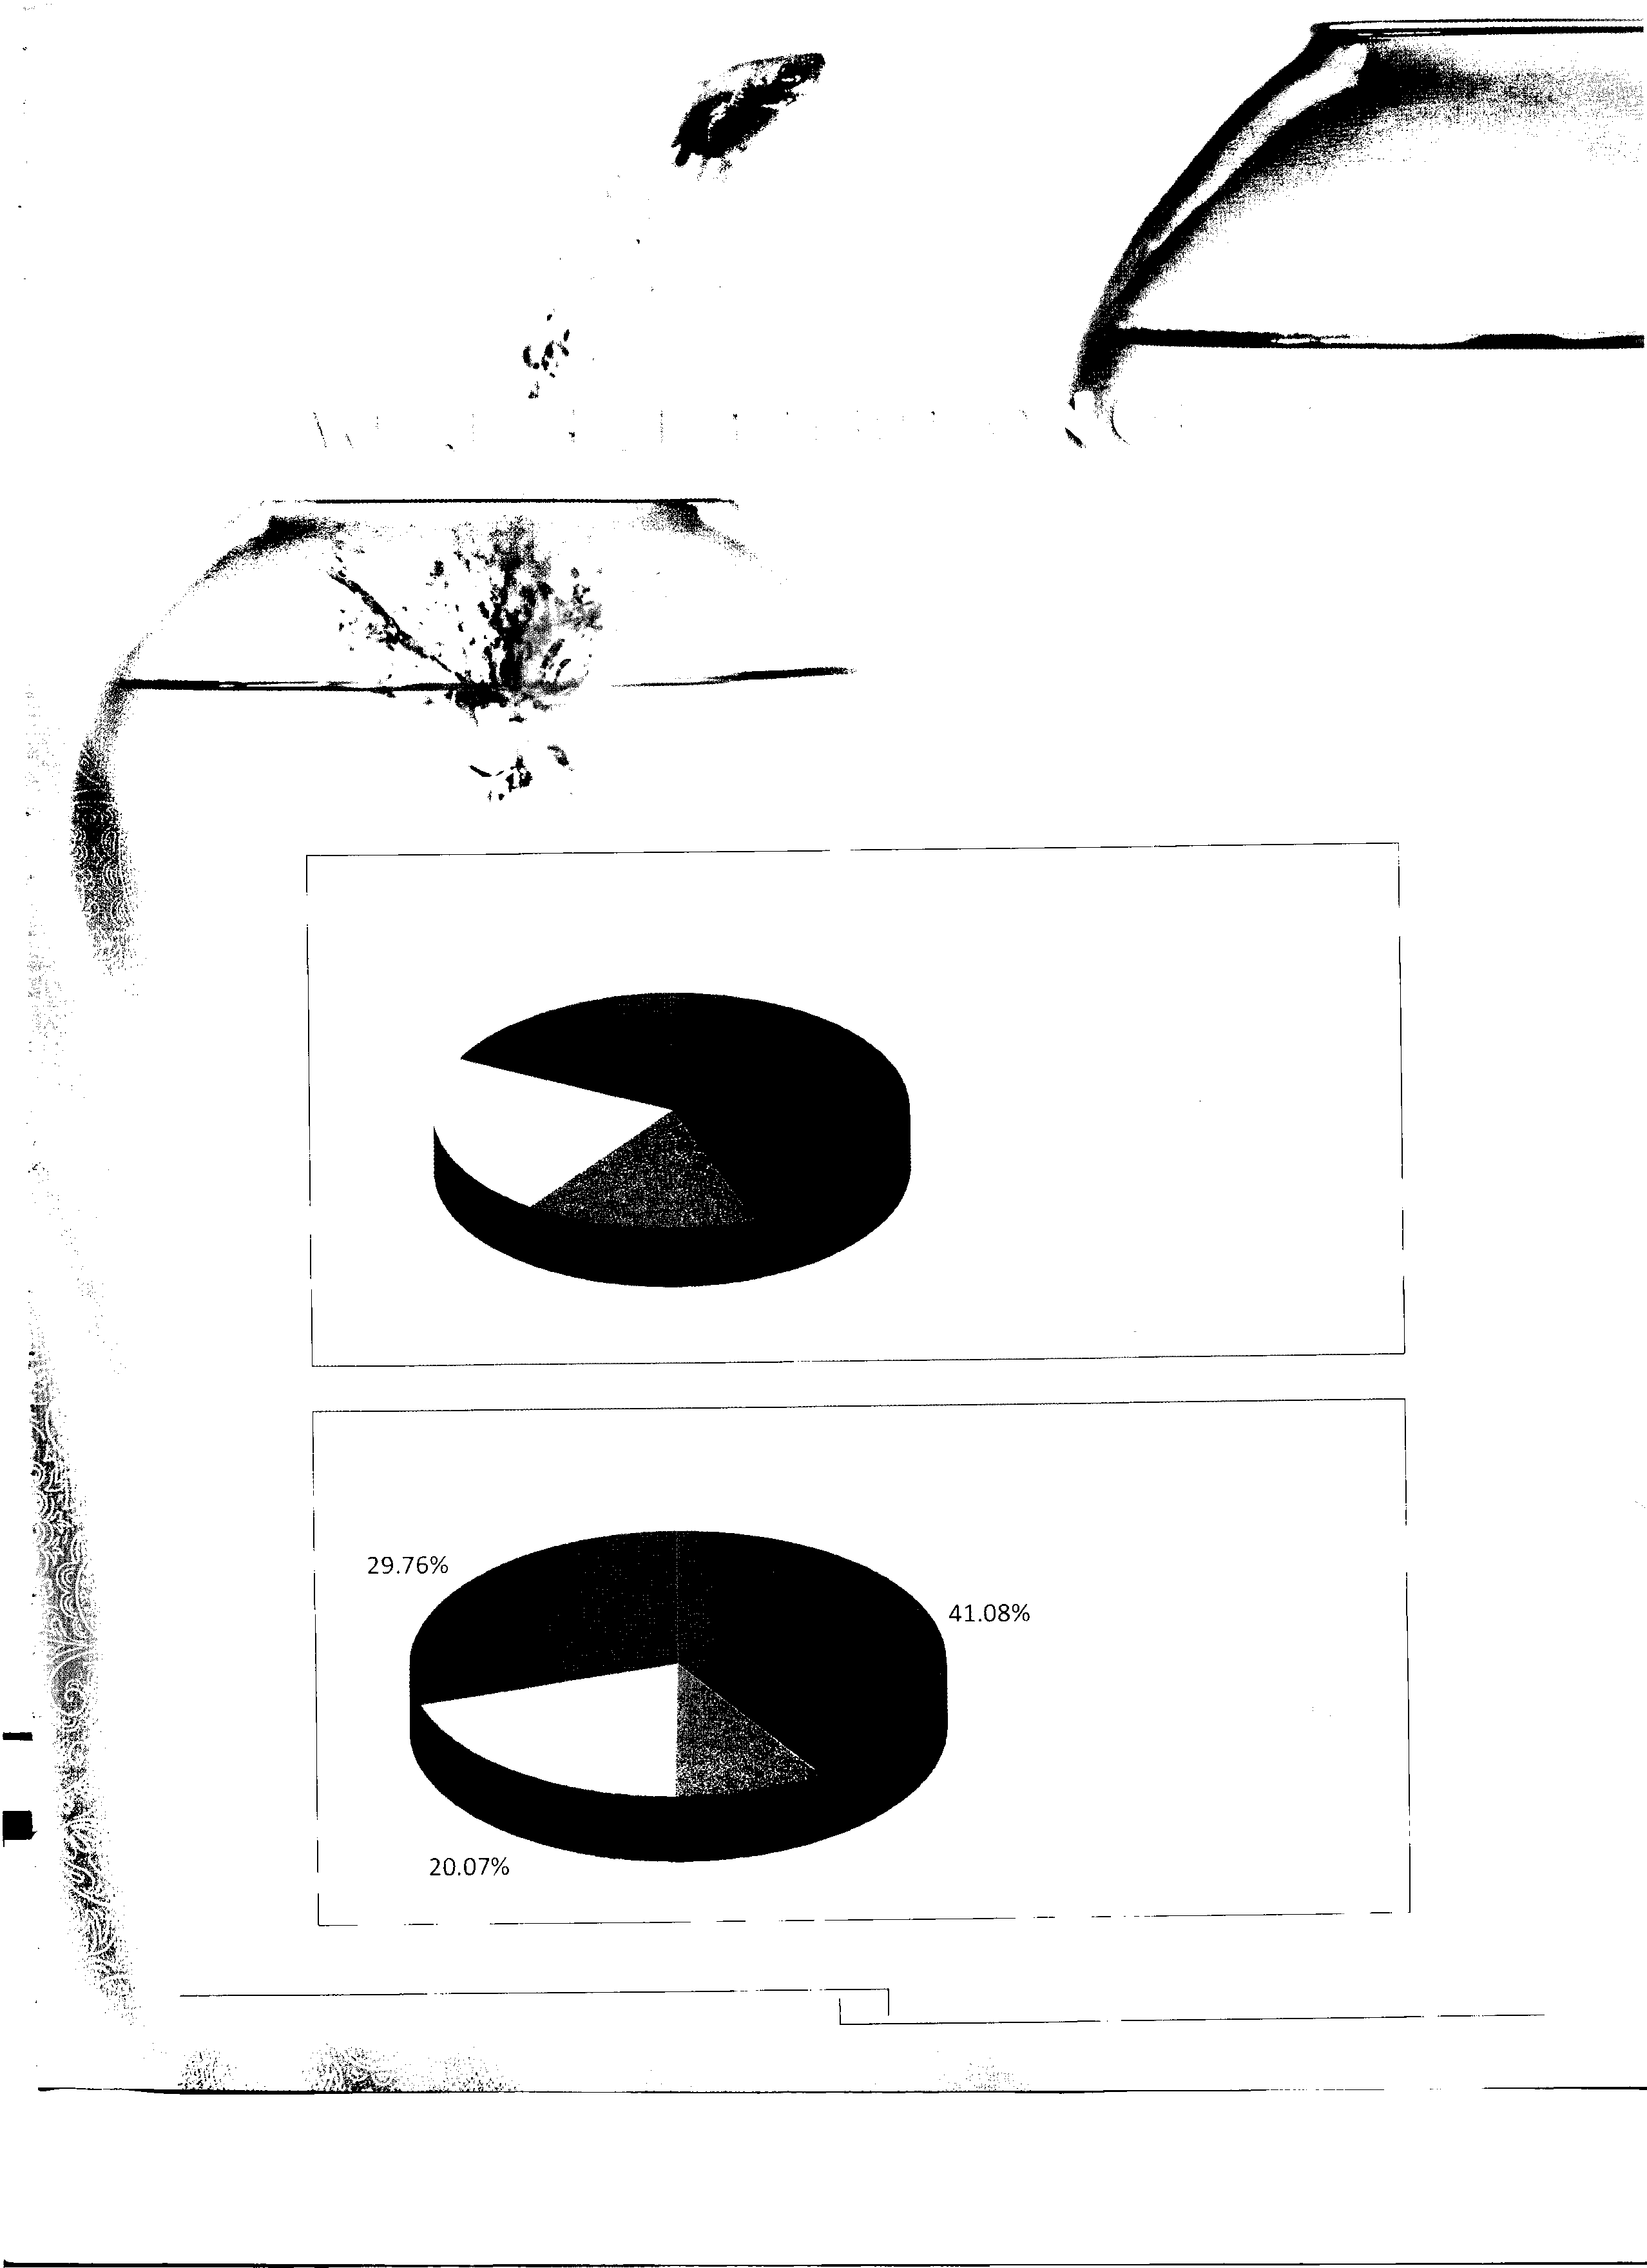

15.63%

2013

9.09%

11
• To Provide for Maintenance and Expansion of Assets

• To Employees

§I To Govt.

To Providers' of Capital

• To Provide for Maintenance and Expansion of Assets
Kohinoor Spinning Mills Limited Annual Report
2014
�

FINANCIAL HIGHLIGHTS OF LAST SIX YEARS

Year ended June 30
2014 2013 2012 2011 2010 2009

Profit and Loss Summary
Sales-Net Pak-Rs. 6,822,993, 716 6,230,120,498 5,627,854, 703 6,809,167,296 4,214,153,122 2,885,618,941
Gross profiV(Loss) Pak-Rs. 747,432,402 846,697, 751 563,714,413 898,296,612 667,300,903 240,088,882
Operating Profit/(Loss) Pak-Rs. 472,318,028 573,736,076 383,234,950 677,820, 752 477,883,403 79,094,088
Profit/(Loss) before Tax Pak-Rs. 189,182,609 309,694,041 155,928,819 362, 751,628 173, 742,195 (191,206,782) Profit/(Loss) after tax Pak-Rs. 120,952,672 265,523,955 106,403,464 291,567,330 143,474,219 (202,232,077) Profit before Interest.tax, depreciation and Pak-Rs. 539,429,162 638,861,412 456,180,125 729,804,432 542,743,140 149,326,869 amortization (EBITDA)

Balance Sheet Summary
Share Capital Pak-Rs. 650,000,000 650,000,000 650,000,000 650,000,000 1,300,000,000 1,300,000,000
Accumulated Profit/(Loss) Pak-Rs. 488,020,366 377,513,397 130,639,714 23,873,673 (916,612,715) (1,059,845,770) Shareholder's Equity Pak-Rs. 1,138,020,366 1,027,513,397 780,639,714 673,873,673 383,387,285 240,154,230
Non Curren Liabilities (Excluding loan from Pak-Rs.
directors)
254,512,419 192,015,363 279,047,115 195, 742, 780 375,036,922 608,031,253
Loan From Directors Pak-Rs. 700,000,000 397,000,000 397,000,000 397,000,000 397,000,000 397,000,000
Current Assets Pak-Rs. 2,374,470,897 2,127,045,965 1,402, 754, 738 1,329,721,732 1,472,304,665 1,369,116,687
Current Liabilities Pak-Rs. 2,288,975,876 2, 102,607, 774 1,502,740,142 1,326,950, 732 1,527,763,747 1,347,930,632
Working Capital Pak-Rs. 85,495,021 24,438,191 (99,985,404) 2,771,000 (55,459,082) 21,186,055
Property, plant and Equipment Pak-Rs. 1,979,823,212 1,566,318,684 1,538,351,388 1,247,945,081 1,199,288,501 1,218,664,852
Other Non Current Assets Pak-Rs. 27,214,551 25,771,885 18,320,845 15,900,372 11,594,788 5,334,576
Total Assets Pak-Rs. 4,381,508,661 3,719,136,534 2,959,426,971 2,593,567,185 2,683,187,954 2,593, 116, 115
Total Liabilities (Excluding loan from directors) Pak-Rs. 2,543,488,295 2,294,623,137 1,781,787,257 1,522,693,512 1,902,800,669 1,955,961,885
Total Borrowings Pak-Rs. 1,913,261,694 1,743,692,693 1,442,908,251 1,091,070,483 1,474,221,695 1,525,427,836
Capital Employed Pak-Rs. 3,051,282,060 2,771,206,090 2,223,547,965 1,764,944,156 1,857,608,980 1,765,582,066

Cash Flow Summary

Cash flows of Operating Activities Pak-Rs. 38,311,172 (178,894, 784) 9,504,158 505,610,781 96,949,888 (248,025,213) Cash flows of Investing Activities Pak-Rs. (505,233,243) (122,959,889) (361,886,360) (115,467,898) (44,673,616) (78, 762,920) Cash flows of Financing Activities Pak-Rs. 468,247,389 305,009,656 351,825,419 (386,160,235) (50,629,496) 319,626,098
Net change in cash and cash equivalents Pak-Rs. 1,325,318 3,154,983 (556,783) 3,982,647 1,646,776 (7,162,035)
Cash and cash equivalents at the end of the Pak-Rs.
year

Profitability and Operating Ratios
10,910,083 9,584,765 6,429,782 6,986,564 3,003,916 1,357,140
Gross Profit Margin % 10.95 13.59 10.02 13.19 15.83 8.32
Net Profit to sales % 1.77 4.26 1.89 4.28 3.40 (7.01) PBITDA margin to sales % 7.91 10.25 8.11 10.72 12.88 5.17
Return on Equity % 10.63 25.84 13.63 43.27 37.42 (84.21)
Return on Capital employed % 3.96 9.58 4.79 16.52 7.72 (11.45) Liquidity Ratios
Current Times 1.04 1.01 0.93 1.00 0.96 1.02
Quick/Acid test Times 0.22 0.21 0.16 0.28 0.28 0.29
Cash to current liabilities Times 0.005 0.005 0.004 0.005 0.002 0.001
Cash flows from Operations to sales Times 0.006 (0.029) 0.002 0.074 0.023 (0.086) Activity/Turnover Ratios
Inventory Turnover Times 3.42 3.80 4.78 5.91 3.53 3.13
No. of Days in inventory Days 107 96 76 62 104 116
Debtors Turnover Times 17.9.9 19.37 38.12 31.53 25.67 32.59
No. of Days in Receiveables Days 20 19 10 12 14 11
Creditors Turnover Times 18.46 21.42 54.23 25.08 11.56 7.74
No. of Days in Payable Days 20 17 15 32 47
Total Assets Turnover Times 1.68 1.87 2.03 2.58 1.60 1.57
Fixed Assets Turnover Times 3.45 3.98 3.66 5.46 3.51 2.37
Operating Cycle Days 107 98 79 59 86 80

Investment/Market Ratios

Earning/(Loss) Per share Times 0.93 2.04 0.82 2.24 1.1 (l.56) Capital Structure Ratio
Gearing Ratio % 62.70 62.92 64.89 61.82 79.36 86.40

Kohinoor Spinning Mills Limited
Annual Report
2014

"c:'
ID ID 0 ... en Lil N ,.... ... ... N
ID
co .,, .,, ,.... ,.... en ... 0
l/) m

e..n. Lil en m
ID en

0 ,.... co co m
.,,
q- en 0 en
...-
en 0
0 vi=
co ID N
...; ...;
... N ... �
....
.m..-
.,,
'
N m ID
, .,,
...;
0 a::� N
N
c:
...

<D q- 00 00 q- 0 0 <D ..... l/) .....

N r-, 00 er,

0 00 m er,
u "Q'I
q- m r..-..,.
..... 0 ..... I.O N O...".I.
r..-..,.
,....
.....
.....
<D � .....
QI QI >-
....
Ill) 0
*"' ::::: "'
u --'
E vi
>

.,, ,.... ,.... en co .., 0 en q- 0 ..,

en N N f1'I

m ,.... .,, co m
"c:'
... ,::t ID co ,.... 0 ... ,....
,::t
a, ... ,.... co
m m m
...,- ID
... 0
... ,::t m
... m ...
co en ,.... N co
0 vi=
N a::�
N Lil ID
q-' m'
... ,:f ID
,....· ,....· N'
,..;
E
...

N r-, l/) I.O N 0 er, I.O 0) l/) er,

I,..O..

. 00 er, er,
u "Q'I
I.O I.O er, ..... q- -o..... N
..... ...r.,.
0.....
.:!.� -
QI QI >-
.....
Ill) 0
*"' ::::: "'
u --'
E vi
>
"c:'

0 ... en N ,.... 0 N ID ,.... en
en ... co 0 co N 0 ID .., ... N

co ID 0 .,,
...
N'
,::t m a,

.,.,..,.
ID

,....
en

,.... .,,
en N en
...
0
N
0
a::�
vi=
c:
co en co N ID m m N
ID Lii
...- .... .,,
ID m ...
.,,
...- N'
VI ...
u "'
iii
> QI
..J QI QI >-
Ill) 0 .....
< u --'
..J E vi
<
;::::-�;::::-00,;,;;:,;;:, q- ;::::-0�
� !::. � !:!. � � .:!}. q- ���

er, l/) l/) q-
..... .....
N

I...O..

er,
q- .....
' er,

.....
N'
Iz-
>
co q- q- 0 m co en en ID 0 ID
co co .., en
... ,.... en m en
0 "c:'
N N 0
N ID ID co co N Lil Lil 0
.m,,
...
.,,
.,,
c,..o..
en ,.... 0 .,,
ii: ... vi=
ID 0 Lil ... m N ... ...
Lil- Lil-
...- ...- en
m N L..il. en
0 0 a::�
N
::c E
...
u Q"'I
QI QI >-
Ill) 0 ....

..... <D 0 ..... 0 l/) 0) 0) 0) ..... 0
..... .....
l/) l/) l/) ..... I.O 0) l/)
.....
N

N ..... N I.O
q- l/) N
N'

N ..... 0 I.O
er, er, q- N
*"' ::::: "'
u --'
c: vi
>

0 m ,.... m q- co co .., 0 ,::t ID

ID ID ,.... a,

co ,.... N m en
N en en 0 ...
m...
=
"c:'
0
m co .,, ,.... ,.... m N ... ,::t ID
N N Lil N
m co m N
I.D,,
N ... .,....
...- m ... ... ,.....,.,
0 i.n
N

u
..E.
"Q'I
ID Lii

..... ...r.,. ..... ..... 0...0.. 0) ;:::-om q- �
��� l/) �
...- ...; ..,,

N ..... .....
I.O I.O N 00

.....

I,..O..
N'

er, 0) 00
.....
er,
QI QI >-
Ill) 0 .....
*"' ::::: "'
u --'
E
vi
>

m ID ,.... Lil N 0 .,, 0 en co ...
ID N co
0 ,.... N .,, N

co 0 .,, en N

"c:'
...
,::t 0
co ,.... .,, ,.... ,.... ... ID
...
....- ,....
.,, co co
N N m
0 "'=
ID ID
N' .,,-
N a::�
c:

"Q'I VI
VI ..... �"'
c: c:
QI QI :c
w
0x.. VI
E VI "'
... UJ QI
0.. ..... ;:::; VI
QI
c c: -;;;- VI "' :::, VI "Cl �
x QI QI
:I 0 VI
c: E f- x cr VI c VI
u :::, --' x u
....

?;' ·5 E
:-E �
0 ·.;::; 0 0.. 0 QI 2 UJ "' � VI QI :.0
QI <(
-0
u ..0 UJ
c: ..0.. ai
c: c:
·5 :.a
< ·.:::
-...-..
Ill) Ill) QI ,±:'. ... "' t
C" cr u
:":;'
VI
QI -0
VI .....
<;:: c: c: ..0
.;::;
"'
.... UJ � � c:
VI
0 VI
..,
VI e
<l.
c5
.....
.::; ·
-;;;- -;;;-
VI VI
Qj
..c
"'
c:
0..
:::, VI
u QI
0
VI
QI
VI -.V.I. c5 .....
QI
t
:.a
"'
cr
">'-
..J
"Cl .....
QJ <;:: -0
VI � �
0 0
0.. --' --
.!!! c:
VI .:'.!
-:;;
c:
E ::;
e
..,
..�
"iii
c: bO O
QI QI
.. .....
"Cl -0
c: QI Vl
"' 0 0::::: c: Qj
> 2 VI
cu
"' .;::; QI
0..
...
=- VI
t:'.
<( VI
0 :::,
:::,
7 .... <l.
e
0
e
.Ec u 0 u
0
c <( ..c ..c LL c UJ
�
0
... ·
..,
·.;::;
..,
c VI .V.I. u
t;::
QI .....
VI "' c QI
ai <;:: "x' e
e "'
� c:
VI
VI "' ....c,
ai
..c
QI
<;:: Qj 0..
..c
QI
0
� c
"' "'
t .....
� iii u
VI
-0
0 iz: 0
0 e "'
VI :5 0
u
..c
0 :::, "'
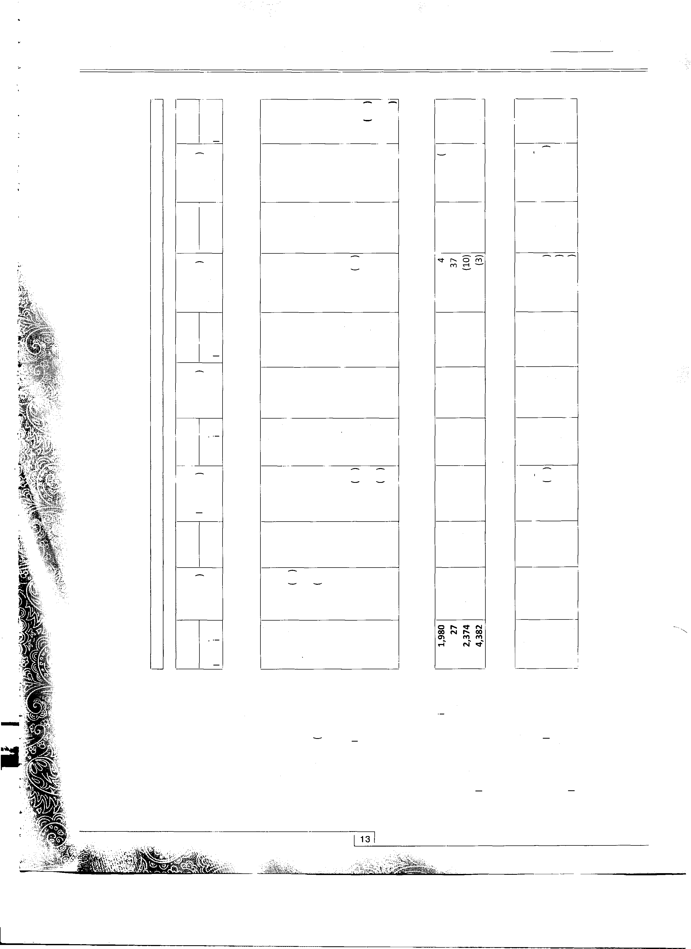0 0
Vl (.!) <(
0.. c:
ia
<l. f- <l. al
"'
<
VI
<l.
f- V"I'
..c 0
Vl --'
2 u f-

Kohinoor Spinning Mills Limited
Annual Report
2014

0 r-, m � 0 :!. £ 0 LI) ..-< <:t
0 e ..-< ..-< -
..-<

-- cr, .... 00 0 00 NO ID t"I\ .... N
.... cr, ,.... e, cr,
-
v, 0 N 0 N ID
00 ..-< ..-< 0
<:t LI) 0
..-<

0 ID 0 <:t
....
,.;
...... t"I\ cr,
co LI) 00 ..-< 0
N ..-< LI) 0
..-<

.... ,.... ID ,.... <:t
" cr, cr, N cr,
N•
c
.... 2
00 cr, 00 � ID � t"I\ N
ID• �
N....-
t."..I.-\ .,,
ID t"I\ .... t."..I.\- .,,
B �
NE
vi
c::

(1)
trloO
*-

0 0 0 � r-, :!. £ 0 m ..... N
0 � ..-< -
..-<

N ..... r-, 0
"'
LI) <:t 0
..-<

m en ..-< 0
N ..-< LI) 0
N•
..-<
00 �
�
v,
0 t"I\ co -cr, cr, I.D,, 0 ID

00 00 t"I\ cr,
N•
.... ,.... cr, t"I\ en
N ID i
00 00 N
0 t.",I,\ .... 0 .,,
,..0..
en ,....
.,,
o.n
c ID 0 o.n .... t"I\ � .... ....
�
2 LI\
N
.... .<.:.t. cr,
m N ....- en
82
N c
v,
c::

0 G' <:t s. en :!. £ 0 LI) ..-< er

N rl ,.... 0

00 ..-< LI) r-, 0
0
..-<
e ..-<
<:t LI) 0.....
N ..-< LI) 0
..-<

0 t"I\ ,.... t"I\ <:t 00 00 t"I\ 0 ID
,.... ,.... ....
-
3
v, t"I\ 00 <:t t"I\ N ID
ID ID ,.... cr,
ID N N
....
....
00 ,.... N t"I\ en
N cr, cr, 0
....
N• ..,;-
c
,g
t."..I.\
2
0
N t"I\ 00 � .,, � t"I\ -N
ID. �
o.n .... ,....
N' ..,;-
.... t"I\ .... .... ,....
N E
vi
c::

0 en ..-< s, r-, :!. £ 0 m ..-< N
LI) ..-< <:t 0
"N' "....'.
"' N 0

(1) eo ro
*-
0.....
..-<
<:t LI) 0
..-<
LI) 0
..-<
t"I\ ID ,.... i:ii N s� 0 cr, co ....

0 <:t N

00 0 o.n cr, N
....-
N ,.... <:t ,.... ,.... ID -N 00 N
00 "N ,.... 00
t."..I.\ 0 .,, 00 00
v,
c
,g
�
.<..:t.
0
N E
vi
c::
00 0
ui �
,....
� <:t �
.... � ....
cr, t"I\ t"I\
N• ..;-
....
.... " N
N t"I\
N•

"QJ'
c
<(
v, �
(1) .., 1i
v,
c ro
(1) (1) :::;
0x. v, E
...
0. tl "'C v,
U.J (1) QJ x ·3 (1) e QJ
v,
c c -;;;- c E ro v, ro :-E
::, 0 v,
.....
x CT
v, ... v,
-�
(1) 0 I-
.".,' U.J ..,
> v, (1) :0
.E (1) c
::::, s v,
0 ·;:; 0 0. u �
..._ -a c ·5 .� :E
u ::::, x E
�
e
u ..c U.J
<( E tlO tlO Q)
"'
.;:'.
"'
QJ
�
...
.".,' �
er
w
-...
CT u
:0
..,
g -a
"' ..,
<ii
c
·;:; :;;
..c
-;;;- -;;;-
u tl
v, � "'
v, c
.., �
.,,
c ::::,
U.J
"'
:::; c
..0...
v, 0
v, [:' "'
QI "'
(1) QJ
-..._
0 :.0
">'
"'C
..'!!
<;::: -a
tlO
v, v,
0 (1) 0 0
0. c v, ti Q) c
0 v, Q) "'C -a E �
v,
CT
e
::":';
·'=
c .., V"'l 0 c
E
ro
c u 0.
0. .....
c :=.
z .., �
::::,
.., ::::,
(1)
7 0
v,
·;:; (1) 0
..,
QJ
.., "'
·
v
> <(
t c ..c u.. c U.J
f
...
a:
v, [:' c
0::::::
..._
...
�0 0
."c'
u ..._
..._
0
;:; c
..._ u
(1) c
...
Q) .., "0'
(1) "c' ....c, ..c
�
x 0 "' 0 ..c :i
ro � "'
;; Q) Q)
<;::: "' ro
(1)
0. �
�
0
Cl.
"iii
u"' 19
<( 0 u::: 0 �e
Q)
a: 0
0"'
.,,
.."c'
c
..0... z0 u
::::,
0"'
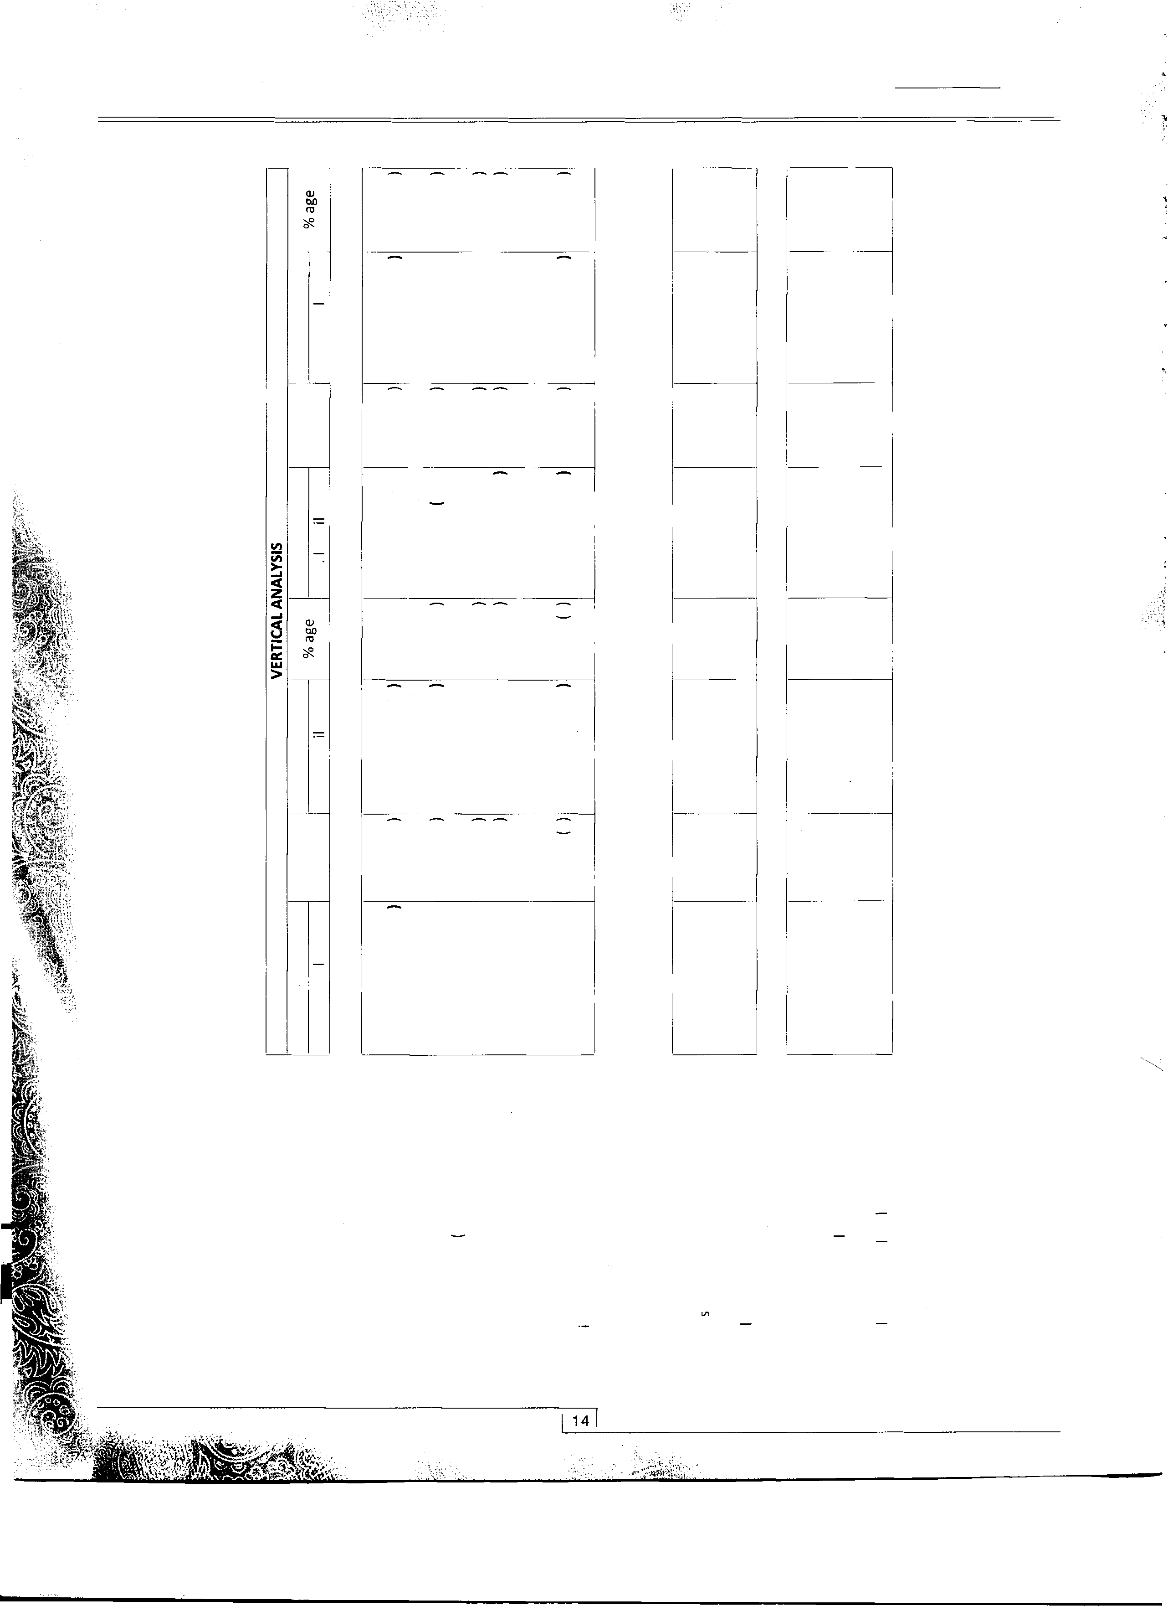0 -a 0.
Vl
0 I"-' a:
iii
al
<"('
u I- Vl I-
Sales

"c'
7,000
6,000
5,000
G, RA·. A.ML t. ,.,e,$..i.,.'.�""L-'"·
� ��
;.i
Vd
�·e 4,000
.5 3,000
� 2,000
1,000
. P R��:S'._�i �iT

, ... ·,,,·,

"c'
�·e

1,500

1,000

Shareholders' Equity
OF ii�::\
FINANC1IA1�

HIGHLIGHJ::S
.5 500
.;
a:

Year 2009 2010 2011 2012

2,000

� 1,500
�·e

2013

2014
1.000
.5
g 500

2010

"c'
·�e
.s
600
500
400

300
.; 200
a: 57
100
-�

2009
2010 2011
2012 2013 2014

"c'
900
800
700
600
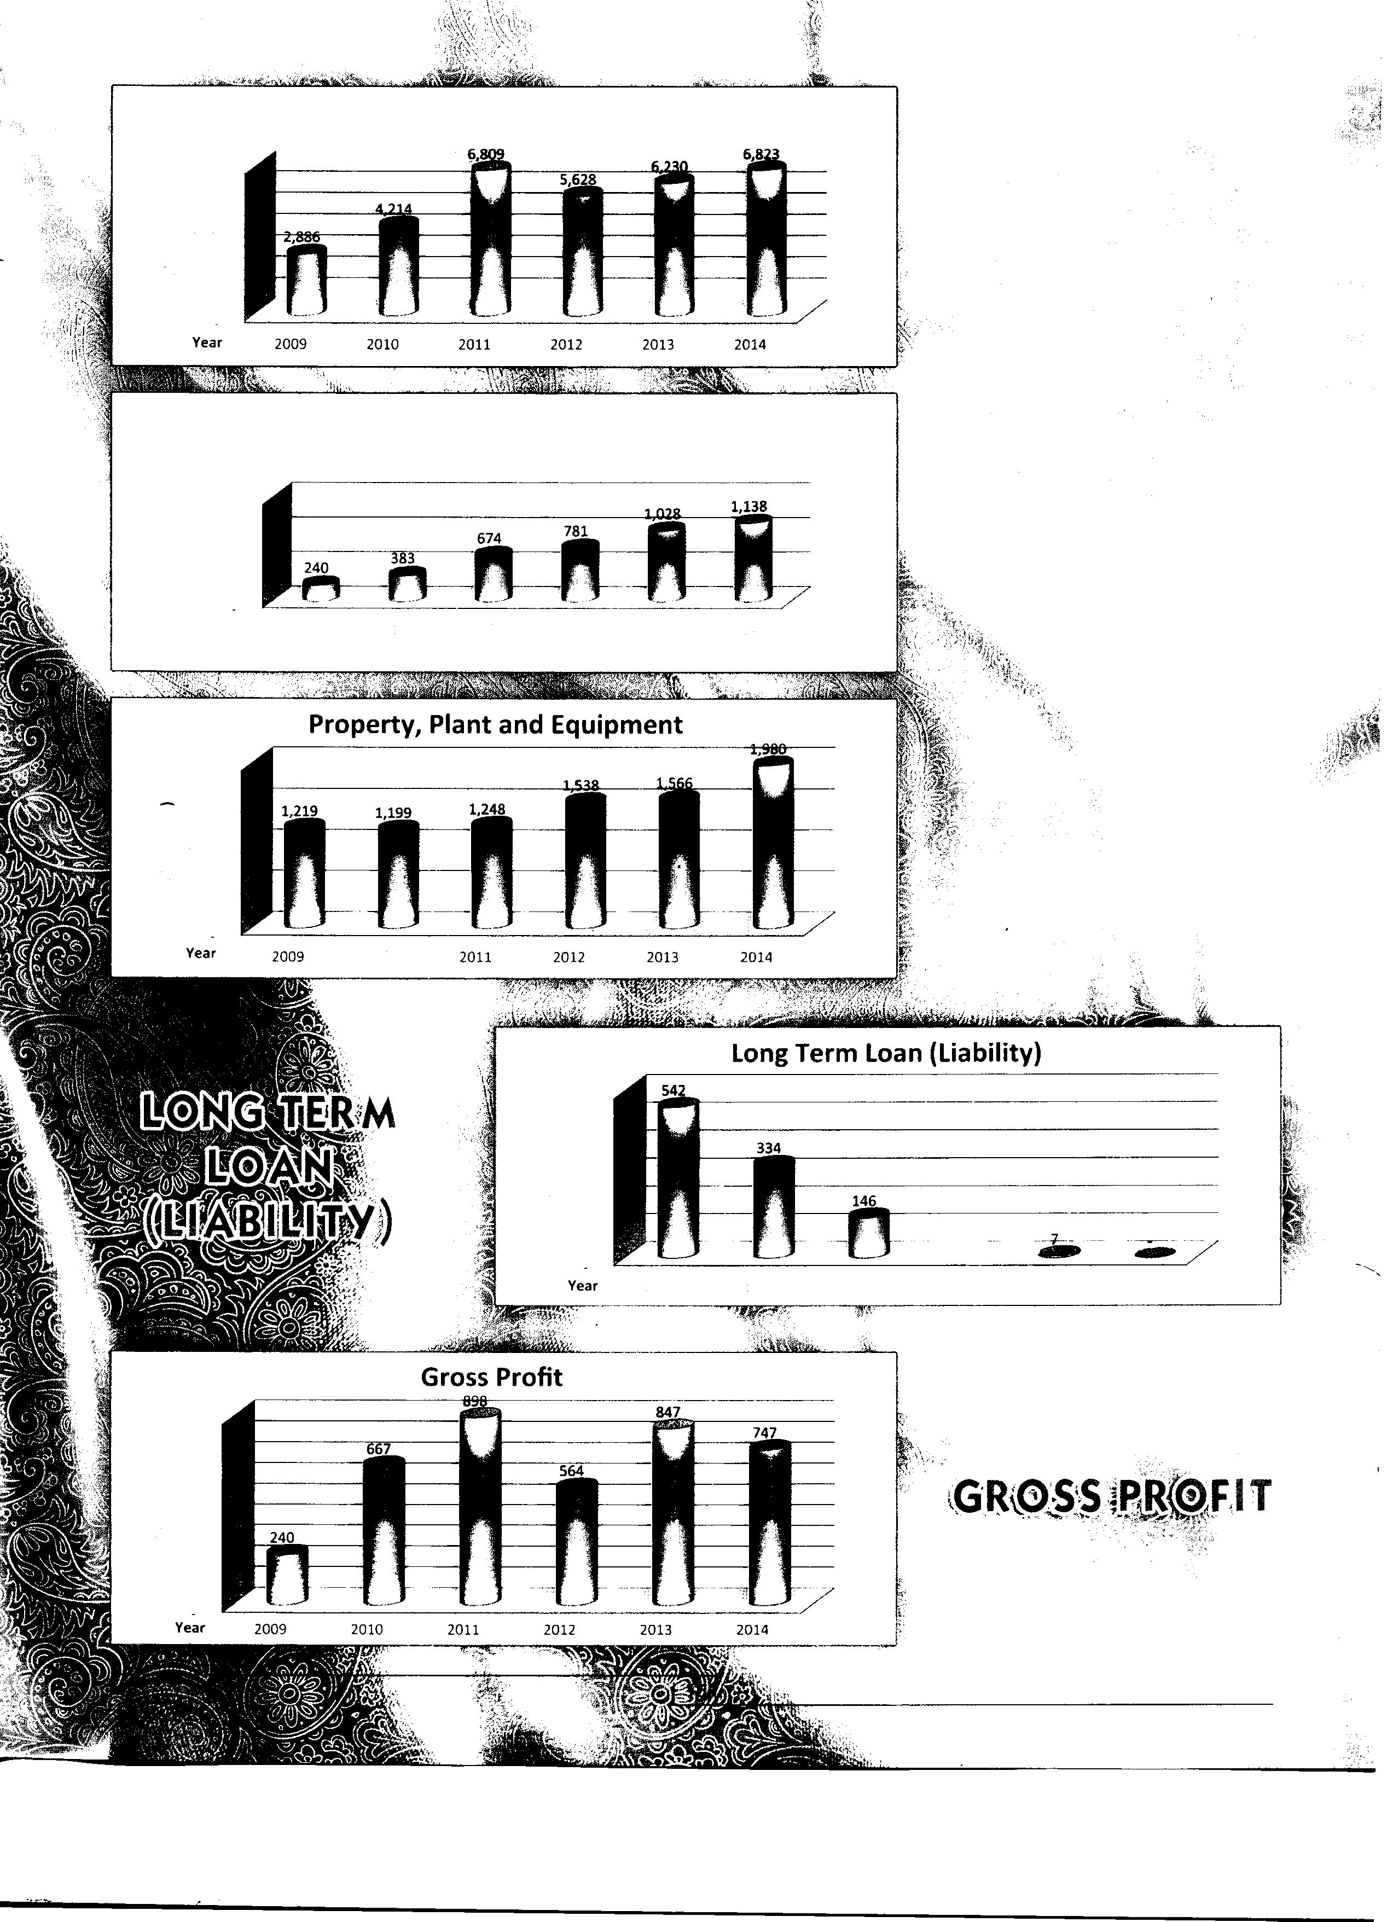�·e 500
.s 400
.; 300
a:
200
100

a1:i=:e1Af'(i1f \(((1):111,r,11,iia'ru!i W1i1th the ,.c,o.· te
,of \Corporate .Gov.e.rnance

This statement is being presented to comply with the Code of Corporate Governance (CCG) contained in regulation No. 35 of listing regulations of Karachi Stock Exchange for the purpose of establishing a framework of good governance, whereby a listed company is managed in compliance with the best practices of corporate governance.(CCG)

The company has applied the principles contained in the CCG in the following manner:
5. The company has prepared a "Code of Conduct" and has ensured that appropriate steps have been taken to disseminate it throughout the company along with its supporting policies and procedures.

6. The Board has developed a vision /mission statement, overall corporate strategy and significant policies of the company. A complete record of particulars of significant policies along with the dates on which they were approved or amended has been
maintained.
1. The company encourages the representation of independent non-executive directors on its Board of Directors. At present the Board includes -

7. All the powers of the Board have been duly exercised and decisions on material transactions, including appointment and
determination of remuneration and terms and condition of
Category

Executive Directors 1 .
2.

Non Executive Directors 1 .
2.
3.
4.
5.
Names

Khawaja Mohammad Javed
Khawaja Mohammad Naveed

Khawaja Mohammad Jahangir Khawaja Mohammad Tanveer Khawaja Mohammad Kaleem Khawaja Mohammad Nadeem
Mr. Mohammad Hamza Yousaf
employment of the Chief Executive and other working director(s)
have been taken by the board/shareholders.

8. The meetings of the Board were presided over by the Chief Executive or in his absence other director elected by the board for this purpose. The Board met at least once in every quarter. Written notices of the Board meetings, along with agenda and working papers were circulated at least seven days before the meetings. The minutes of the meetings were appropriately
recorded and circulated.

Independent Director
1. Mr. Muhammad Tariq Sufi
9. Mr. Mohammad Hamza Yousaf, Director of the Company has completed directors training program during the year through
2. The directors have confirmed that none of them is serving as a director on more than seven listed companies, including this company.(excluding the listed subsidiaries of listed holding companies wherever applicable)

3. All the resident directors of the company are registered as taxpayers and none of them has defaulted in payment of any loan to a banking company, a DFI or an NBFI or, being a member of stock exchange, has been declared as a defaulter by that stock exchange.

4. No casual vacancy occurred in the Board during the year.
Institute of Chartered Accountants of Pakistan. The other directors of the company are exempted from directors training program due to 14 years of education and 15 years of experience on the board of listed company which covered compliance of Code of Corporate Governance.

10. The Directors at Kohinoor Spinning Mills Board are fully conversant with their duties and responsibilities as Director of corporate bodies. The Chief Executive recommends that the members of the Board should approach him, should they feel any necessity to conduct other orientation courses in this
regard.

16

11 . The Board has already approved appointment of Chief Financial Officer, Company Secretary and Internal Auditor, their remuneration and terms & conditions of employment.

12. The director's report for this has been prepared in compliance with the requirements of the CCG and fully describes the salient matters required to be disclosed.

13. The financial statements of the company were duly endorsed by CEO and CFO before approval of the Board.

14. The directors, CEO and executives do not hold any interest in the shares of the company other than that disclosed in the pattern of shareholding.

15. The company has complied with all the corporate and financial reporting requirements of the CCG.

16. The Board has formed an Audit Committee, It comprises of three members, of whom all are non executive directors and the chairman of the committee is an independent director.

17. The meetings of the Audit Committee were held at least once every quarter prior to approval of interim and final results of the Company and as required by the CCG. The terms of references of the committee have been formed and advised to the committee for compliance.

18. The board has formed an HR and Remuneration committee; It comprises of three members, including the CEO and the non executive directors while the chairman of the committee is a
non executive director.
20. The statutory auditors of the company have confirmed that they have been given satisfactory rating under the quality control review program of the ICAP. that they or any of the partners of the firm, their spouses and minor children do not hold shares of the Company and that the firm and all its partners are in compliance with International Federation of Accountants (IFAC) guidelines on code of ethics as adopted by ICAP.

21. The statutory auditors or the persons associated with them have not been appointed to provide other services except in accordance with the listing regulations and the auditors have confirmed that they have observed IFAC guidelines in this regard.

22. The "closed period" prior to the announcement of interim/final results and business decisions which may materially affect the market price of Company's securities, was determined and intimated to directors, employees and stock exchange(s).

23. Material/price sensitive information has been disseminated among all market participants at once through stock exchange( s ).

24. All related party transactions entered during the year were at arm's length basis and these have been placed before the Audit Committee and Board of Directors. These transactions are duly reviewed and approved by Audit Committee and Board of Directors.

25. We confirm that all other material principles enshrined in the
CCG have been complied with.

19. The Board has set up an effective internal audit department which is suitably qualified and experienced for the purpose
• and is conversant with the policies and procedures of the
company.

Lahore:
1 O October 2014

Mohammad Naveed
Chief Executive Officer

17
_,,,,,- Member Firm of
::::: UK200Group
lndependenl quality assured professionals

Aslam Malik & Co.
Chartered Accountants
Phone : +92-42-35858693-35858694
: +92-42-35856819
Fax : +92-42-35856019
e-mail : aslammalik@brain.net.pk
: info@aslammalik.com web : www.aslammalik.com

Suite# 18-19 First Floor, Central Plaza, Civic Centre,
New Garden Town, Lahore-Pakistan.

REVIEW REPORT TO THE MEMBERS ON STATEMENT OF COMPLIANCE WITH BEST PRACTICES OF CODE OF CORPORATE GOVERNANCE

We have reviewed the Statement of Compliance with the best practices contained in the Code of Corporate Governance prepared by the Board of Directors of Kohinoor Spinning Mills Limited to comply with the Listing Regulation of Karachi Stock Exchange (Guarantee) Limited where the Company is listed.

The responsibility for compliance with the Code of Corporate Governance is that of the Board of Directors of the Company. Our responsibility is to review, to the extent where such compliance can be objectively verified, whether the Statement of Compliance reflects the status of the company's compliance with the provisions of the Code of Corporate Governance and report if it does not. A review is limited primarily to inquiries of the company personnel and review of various documents prepared by the Company to comply with the Code.

As part of our audit of financial statements we are required to obtain an understanding of the accounting and internal control systems sufficient to plan the audit and develop an effective audit approach. We are not required to consider whether the board's statement on internal control covers all risks and controls, or to form an opinion on the effectiveness of such internal controls, the company's corporate governance procedures and risks.

The Code requires the Company to place before, the Audit Committee, and upon recommendation of the Audit Committee, place before the Board of Directors for their review and approval its related party transactions distinguishing between transactions carried out on terms equivalent to those that prevail in arm's length transactions and transactions which are not executed at arm's length price and recording proper justification for using such alternate pricing mechanism. We are only required and have ensured compliance of this requirement to the extent of the approval of the related party transactions by the Board of Directors upon recommendation of the audit Committee. We have not carried out any procedures to determine' whether the related party transactions were undertaken at arm's length price or not.

Based on our review, nothing has come to our attention which causes us to believe that the Statement of Compliance does not appropriately reflect the Company's compliance, in all material respects, with the best practices contained in the Code of Corporate Governance, as applicable to the Company for the year ended June 30, 2014.

Lahore
October 10, 2014

•

Other Offices at:
Aslam Malik & Co. Chartered Accountants

Audit Engagement Partner: Mohammad Aslam Malik
Islamabad: House# 726, Street 34, Margalla Town, off Murree Road, Islamabad.
Tel: +92-51-2840487-88, Fax: +92-51-2840486

Karachi: Suite# 602-B, 6th Floor, Business & Finance Center, I.I. Chundrigar Road, Karachi
Tel: +92-21-32412212, 32443706 Fax: +92-21-32472235
-::::::,.. Member Firm of
�UK200Group
Independent quality assured professionals

C Aslam Malik & Co.
Chartered Accountants
Phone : +92-42-35858693-35858694
: +92-42-35856819
Fax : +92-42-35856019
e-mail: aslammalik@brain.net.pk
: info@aslammalik.com web : www.aslammalik.com
Suite # 18-19 First Floor, Central Plaza, Civic Centre,
New Garden Town, Lahore-Pakistan.

AUDITORS' REPORT TO THE MEMBERS

We have audited the annexed balance sheet of KOHINOOR SPINNING MILLS LIMITED as at June 30, 2014 and the related profit and loss account, statement of comprehensive income, cash flow statement and statement of changes in equity together with the notes forming part thereof, for the year then ended and we state that we have obtained all the information and explanations which, to the best of our knowledge and belief, were necessary for the purposes of our audit.

It is the responsibility of the company's management to establish and maintain a system of internal control, and prepare and present the above said statements in conformity with the approved accounting standards and the requirements of the Companies Ordinance, 1984. Our responsibility is to express an opinion on these statements based on our audit.

We conducted our audit in accordance with the auditing standards as applicable in Pakistan. These standards require that we plan and perform the audit to obtain reasonable assurance about whether the above said statements are free of any material misstatement. An audit include examining, on a test basis, evidence supporting the amounts and disclosures in the above said statements. An audit also includes assessing the accounting policies and significant estimates made by management, as well as, evaluating the overall presentation of the above said statements. We believe that our audit provides a reasonable basis for our opinion and, after due verification, we report that:

(a) in our opinion, proper book of accounts have been kept by the company as required by the Companies Ordinance,
1984.

(b) in our opinion

(i) the balance sheet and profit and loss account together with the notes thereon have been drawn up in conformity with the Companies Ordinance, 1984, and are in agreement with the books of account and are further in accordance with accounting policies consistently applied except for changes as stated in note
3 with which we concur .

(ii) the expenditure incurred during the year was for the purpose of the company's business; and

(iii) the business conducted, investments made and the expenditure incurred during the year were in accordance with the objects of the company;

(c) in our opinion and to the best of our information and according to the explanations given to us, the balance sheet, profit and loss account, statement of comprehensive income, cash flow statement and statement of changes in equity together with the notes forming part thereof conform with approved accounting standards as applicable in Pakistan, and, give the information required by the Companies Ordinance, 1984, in the manner so required and respectively give a true and fair view of the state of the company's affairs as at June 30, 2014 and of the profit, its cash flows and changes in equity for the year then ended, and

(d) in our opinion Zakat deductible at source under the Zakat and Usher Ordinance, 1980(XVIII of 1980), was deducted by the Company and deposited in the Central Zakat Fund established under Section 7 of that Ordinance.
{}� ,ft�

Lahore
October 10, 2014
-

Other Offices at:

ASLAM MALIK & CO. Chartered Accountants

Audit Engagement Partner: Mohammad Aslam Malik
Islamabad: House# 726, Street 34, Margalla Town, off Murree Road, Islamabad.
Tel: +92-51-2840487-88, Fax: +92-51-2840486

Karachi: Suite# 602-B, 6th Floor, Business & Finance Center, I.I. Chundrigar Road, Karachi
Tel: +92-21-32412212, 32443706 Fax: +92-21-32472235

Kohinoor Spinning Mills Limited
Annual Report
2014

BALANCE SHEET

·i
i

The annexed notes from 1 to 43 form an integral part of these financial statements.
 | Notes | 2014  (Rupees) | 2013 (Rupees)
CAPITAL AND LIABILITIES
SHARE CAPITAL AND RESERVES
Authorised Capital
130,000,000 (2013 - 130,000,000) ordinary shares of
Rupees 5/- each (2013 Rupees 5/- each) |  | 650,000,000 | 650,000,000
Issued, subscribed and paid up capital 130,000,000
(2013 - 130,000,000) ordinary shares of Rupees 5/- each  (2013 Rupees 5/- each) | 4 | 650,000,000 | 650,000,000
Accumulated Profit | 5 | 488,020,366 | 377,513,397
 |  | 1, 138,020,366 | 1,027,513,397
Sub-ordinated loan from directors | 6 | 700,000,000 | 397,000,000
NON-CURRENT LIABILITIES
Long term loan | 7 |  | 7,142,852
Liabilities against assets subject to finance lease | 8 | 36,792,879 | 27,885,024
Suppliers' credit | 9 | 119,363,604 | 73,897,607
Deferred liabilities | 10 | 98,355,936 | 83,089,880
 |  | 254,512,419 | 192,015,363
CURRENT LIABILITIES
Trade and other payables | 11 | 469,415,415 | 410,536,348
Accrued interest on loans and borrowings | 12 | 50,828,993 | 47,972,996
Short-term borrowings | 13 | 1,572,548, 727 | 1,503,481,637
Current portion of non-current liabilities | 14 | 184,869,367 | 135,920,068
Provision for taxation | 33 | 11,313,375 | 4,696,724
 |  | 2,288,975,876 | 2, 102,607,773
CONTINGENCIES AND COMMITMENTS | 15
 |  | 4,381,508,661 | 3,719,136,533

Lahore
October 10, 2014
<2!�
.i>:
(Mr. Mohammad Naveed)
Chief Executive

20

Kohinoor Spinning Mills Limited

AS AT JUNE 30, 2014
Annual Report
2014

.  t··  ·)--  ' .  v!  ;  l  (;':'  l  '.i"-- |  | Notes | 2014  (Rupees) | 2013 (Rupees)
 | ASSETS
 | NON-CURRENT ASSETS
 | Property, plant and equipment | 16 | 1,979,823,212 | 1,566,318,684
 | Long term loans | 17 | 15,863,190 | 14,129,464
 | Long term deposits | 18 | 10,561,342 | 10,561,342
 | Long term investment | 19 | 790,019 | 1,081,079
 |  |  | 27,214,551 | 25,771,885
 | CURRENT ASSETS
 | Stores and spares | 20 | 104,229,569 | 96,834,992
 | Stock-in-trade | 21 | 1,772,659,213 | 1,581,737, 100
 | Trade debts | 22 | 379,248,864 | 321,608,182
 | Loans and advances | 23 | 60,623,579 | 55,202,829
 | Trade deposits, pre-payments and other receivables | 24 | 46,799,590 | 62,078,097
 | Cash and bank balances | 25 | 10,910,082 | 9,584,765
 |  |  | 2,374,470,897 | 2, 127,045,964
.. . ·
i

.. � T
.I/lir The annexed notes from 1 to 43 form an integral part of these financial statements.

21

4,381,508,661 3,719,136,533

(Khawaja Mohammad Jahangir)
Director

Kohinoor Spinning Mills Limited
Annual Report
2014

PROFIT AND LOSS ACCOUNT
FOR THE YEAR ENDED JUNE 30, 2014

 | Notes | 2014  (Rupees) | 2013 (Rupees)
Sales - net | 26 | 6,822,993, 716 | 6,230, 120,498
Cost of sales | 27 | (6,075,561,314) | (5,383,422,747)
GROSS PROFIT |  | 747,432,402 | 846,697,751
OPERATING EXPENSES
Distribution cost | 28 | (152, 142,405) | ( 135,385 ,672 :1
Administrative expenses | 29 | (122,971,969) | (137,576,003)
 |  | (275, 114,374) | (272,961,675)
OPERATING PROFIT |  | 472,318,028 | 573,736,076
Finance cost | 30 | (259,814,814) | (238,489,249)
Other operating expense | 31 | (23,612,354) | (28,422,803)
Other operating income | 32 | 291,750 | 2,870,017
 |  | (283,135,419) | (264,042,035)
PROFIT BEFORE TAXATl ON |  | 189, 182,609 | 309,694,041
TAXATION | 33 | (68,229,937) | (44, 170,086)
PROFIT AFTER TAXATION |  | 120,952,672 | 265,523,955

EARNINGS PER SHARE - BASIC & DILUTED 34 0.93 204

The annexed notes from 1 to 43 form an integral part of these financial statements.

Lahore
October 10, 2014
(Mr. Mohammad Naveed)
Chief Executive

22
(Khawaja Mohammad Jahangir)
Director

Kohinoor Spinning Mills Limited

STATEMENT OF COMPREHENSIVE INCOME FOR THE YEAR ENDED JUNE 30, 2014

2014 (Rupees)
Annual Report
2014

2013
(Rupees)

Profit after taxation

Other comprehensive income

Items that may be reclassified subsequently to profit and loss account Unrealized (Loss)/Gain due to change in fair value of long term investment. Experience adjustment due to acturial valuation (Note 10.1.2)

Total comprehensive income for the year

The annexed notes from 1 to 43 form an integral part of these financial statements.
120,952,672

(291,060) (4, 721, 728)

115,939,884
265,523,955

286,070 (16,459,642)

249,350,383

�;;:;):< '.'
-
..

Lahore
October 10, 2014
(Mr. Mohammad Naveed)
Chief Executive

23
(Khawaja Mohammad Jahangir)
Director

Kohinoor Spinning Mills Limited
Annual Report
2014

CASH FLOW STATEMENT
FOR THE YEAR ENDED JUNE 30, 2014

2014

2013

Note  CASH (USED IN)/GENERATED FROM OPERATIONS | (Rupees) | (Rupees)
Cash generated from operations 35 | 378,451,371 | 120,977,695
Finance cost paid | (256,958,818) | (236,744,145)
Income tax paid | (61,613,286) | (43,037,009)
Gratuity paid | (21,568,096) | (20,091,325)
Net cash (used in)/generated from operating activities | 38,311,171 | (178,894,784)
CASH (USED IN) INVESTING ACTIVITIES Fixed capital expenditure | (504,227,517) | (120,674,097)
Longterm advances | (1,580,726) | (6,984,970)
Proceeds from disposal of property, plant and equipment | 575,000 | 4,699, 178
Net cash (used in) investing activities | (505,233,243) | (122,959,889)
CASH GENERATED FROM FINANCING ACTIVITIES (Decrease) in long term financing | (35,714,290) | (50,000,000)
Increase in long term loan from directors | 303,000,000
Increase in finance lease liabilities | 23,211,305 | 16,355,268
Increase in short term borrowings | 69,067,090 | 399,141,635
lncrease/(decrease) in suppliers credit | 108,683,284 | (60,487,247)
Net cash generated from financing activity | 468,247,389 | 305,009,656
NET CASH INCREASE IN CASH AND CASH EQUIVALENTS | 1,325,317 | 3,154,983
CASH AND EQUIVALENTS AT THE BEGINNING OF THE YEAR | 9,584,765 | 6,429,782
CASH AND EQUIVALENTS AT THE END OF THE YEAR | 10,910,082 | 9,584,765
The annexed notes from 1 to 43 form an integral part of these financial statements.

Lahore
October 10, 2014
(Mr. Mohammad Naveed)
Chief Executive

24
(Khawaja Mohammad Jahangir)
Director

Kohinoor Spinning Mills Limited

STATEMENT OF CHANGES IN EQUITY FOR THE YEAR ENDED JUNE 30, 2014
Annual Report
2014

Share Accumulated
 | Capital  Rs. | Profit  Rs. | Total  Rs.
Balance as on July 01, 2012 - Reported | 650,000,000 | 130,639,714 | 780,639,714
Un-recognized amount due to acturial valuation (Note 5) |  | (1,428,229) | (1,428,229)
Balance as on July 01, 2012 - Restated | 650,000,000 | 129,211,485 | 779,211,485
Interim Dividend for year 2013 |  | (1,048,4 71) | (1,048,471)
Profit for the year after taxation |  | 265,523,955 | 265,523,955
Unrealized gain due to change in fair value of
long term investment |  | 286,070 | 286,070
Experienced adjustment due to acturial valuation |  | (16,459,642) | (16,459,642)
Balance as on june 30, 2013 - Restated | 650,000,000 | 377,513,397 | 1,027,513,397
Interim Dividend for year 2014 |  | (5,432,915) | (5,432,915)
Profit for the year after taxation |  | 120,952,672 | 120,952,672
Experienced adjustment due to acturial valuation |  | (4,721,728) | (4,721,728)
Unrealized gain due to change in fair value of
long term investment |  | (291,060) | (291,060)
Balance as on june 30, 2014 | 650,000,000 | 488,020,366 | 1, 138,020,366

The annexed notes from 1 to 43 form an integral part of these financial statements.

-

Lahore
October 10, 2014
(Mr. Mohammad Naveed)
Chief Executive

25
(Khawaja Mohammad Jahangir)
Director

Kohinoor Spinning Mills Limited

NOTES TO THE FINANCIAL STATEMENTS FOR THE YEAR ENDED JUNE 30, 2014

1. THE COMPANY AND ITS OPERATIONS
Annual Report
2014
1.1 Kohinoor Spinning Mills Limited-and reduced was incorporated on 23rd July, 1970 as a public limited company in Pakistan under the Companies Act, 1913 (Now Companies Ordinance, 1984) and is quoted on Karachi stock exchange. Its registered office is situated at 7/1 E-3 Main Boulevard, Gulberg-111, Lahore. The company is engaged in the business of textile spinning.

2. SIGNIFICANT ACCOUNTING POLICIES

2.1 STATEMENT OF COMPLIANCE

These financial statements have been prepared in accordance with approved International Accounting Standards as applicable in Pakistan. Approved International Accounting Standards comprise of such International Financial Reporting Standards (IFRSs) issued by the International Accounting Standards Board as are notified under the Companies Ordinance, 1984, provisions of and directives issued under the Companies Ordinance, 1984. In case requirements differ, the provisions of, or directives issued under Companies Ordinance, 1984 shall prevail.

2.2 BASIS OF PREPARATION

These accounts have been prepared under the historical cost convention except retirement benefits which have been recognized at present value determined by actuary.

2.3 SIGNIFICANT ACCOUNTING JUDGMENTS AND ESTIMATES

The preparation of financial statements in conformity with approved accounting standards requires the use of certain critical accounting estimates. It also requires management to exercise its judgment in the process of applying the Company's accounting policies. Estimate and judgments are continually evaluated and are based on historic experience and other factors, including expectations of future events that are believed to be reasonable under the circumstances. In the process of applying the Company's accounting policies, management has made the following estimates and judgments which are significant to the financial statements.

Staff retirement benefits

Certain actuarial assumption has been adopted as disclosed in note 7 .1 the financial statements for valuation of present value of defined benefit obligations.

Property, plant and equipment

The Company has made certain estimations with respect to residual value and depreciable lives of property, plant and equipment. The Company reviews the value of assets for possible impairment on an annual basis. Any change in the estimates in future years might affect the remaining amounts of respective items of property, plant and equipments with a corresponding effect on the depreciation charge and impairment.

Income Taxes

In making the estimates for income taxes payable by the Company, the management considers current Income Tax law and the decisions of appellate authorities on certain cases issued in past.

2.4 Adoption of New and Revised Standards and Interpretations

Standards, amendments and interpretations to existing standards that are not yet effective and have not been early adopted by the Company:

-�
;

26

Kohinoor Spinning Mills Limited
Annual Report
2014

Effective date
(annual reporting periods beginning on or after)

IFRS-2  IFRS-3  IFRS-8  IFRS-14  IFRS-15  IAS-16  IAS-19  IAS-24  IAS-32  IAS-36  IAS-38  IAS-39 | Share-based Payments (Amendments) Business Combinations (Amendments) Operating Segments (Amendments) Regulatory Deferral Accounts  Revenue from Contracts with Customers Property, Plant & Equipment (Amendments) Employees Benefits: (Amendments)  Related Party Disclosures (Amendments)  Financial Instruments: Presentation (Amendments) Impairment of assets (Amendments)  Intangible Assets (Amendments)  Financial Instruments: Recognition and  Measurement (Amendments) | July 1, 2014  July1,2014  July 1, 2014  January 01, 2016  January 01, 2017  July 1, 2014 & January 01, 2016  July 1, 2014  July 1, 2014  January 01, 2014  January 01, 2014  January 01, 2016  January 01, 2014
IAS-40  IAS-41  IFRIC 21 | Investment Property (Amendments) Agriculture (Amendments)  Levies | July-1, 2014  January 01, 2016  January 01, 2014

The management anticipates that adoption of above standards, amendments and interpretations in future periods will have no material impact on the Company's financial statements other than in presentation I disclosures.

Further, the following new standards and interpretations have been issued by the International Accounting Standards
Board (IASB), which have not been notified upto June 30, 2014 by the Securities and Exchange Commission of
Pakistan, for the purpose of their applicability in Pakistan:

IFRS-1 - First-time adoption of International Financial Reporting standards
IFRS-9 - Financial instruments
IFRS-10 - Consolidated financial statements
IFRS-11 - Join arrangements
IFRS-12 - Disclosure of interests in other entities
IFRS-13 - Fair value measurement

The following interpretations issued by the IASB have been waived of by SECP:

IFRIC 4

IFRIC 12
Determining whether an arrangement contains a lease

Service concession arrangements
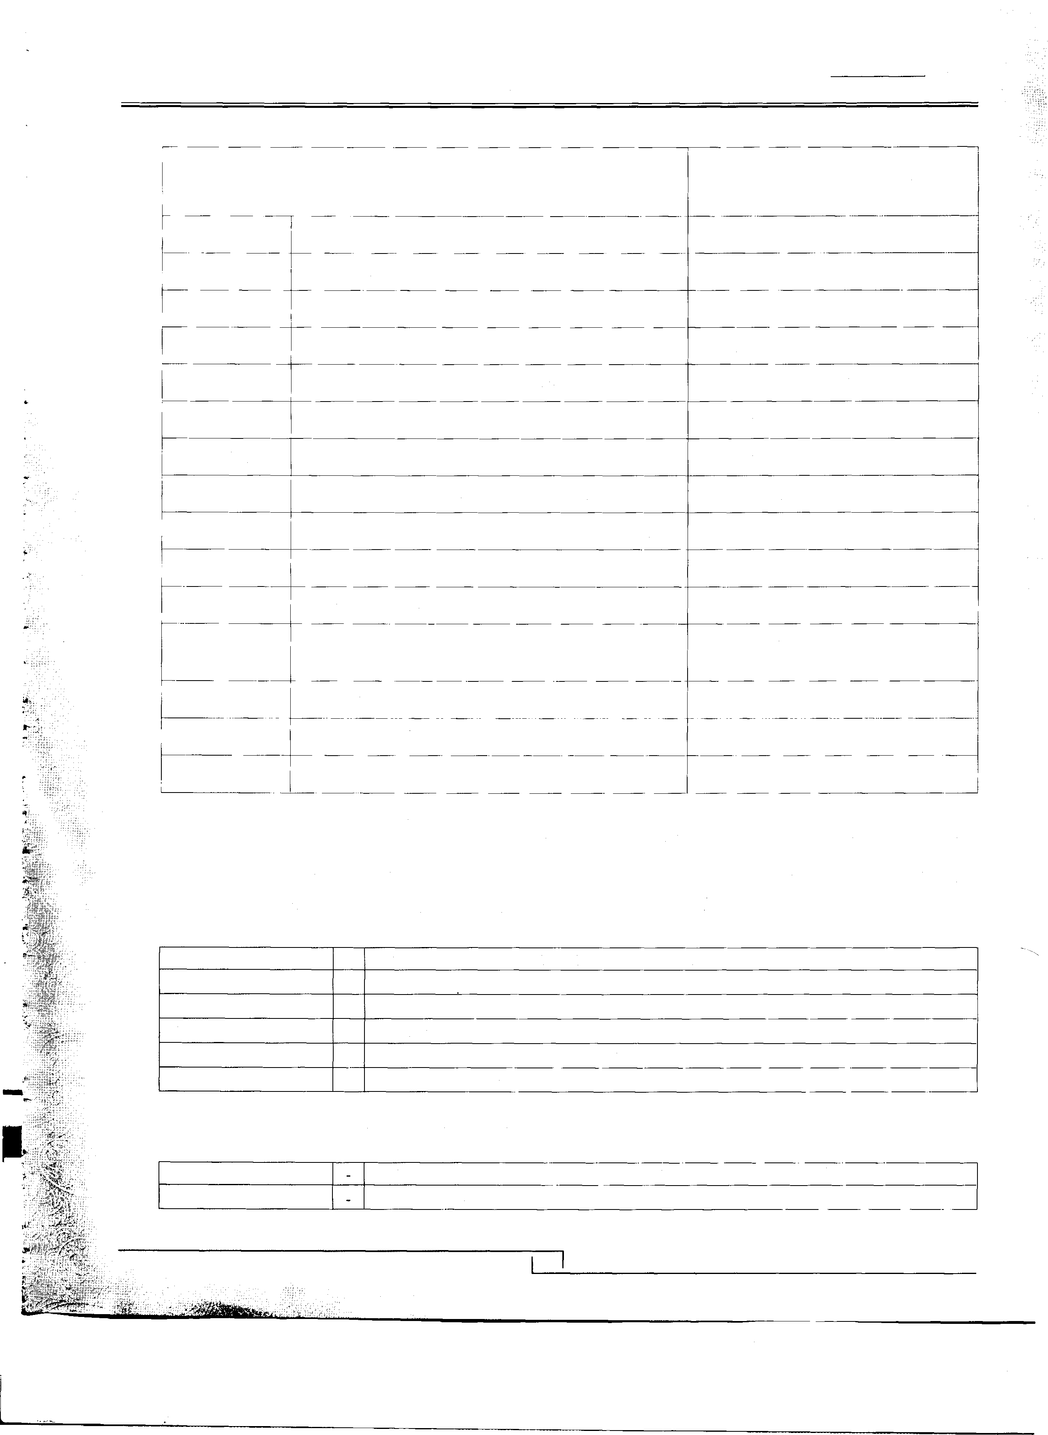

27

Kohinoor Spinning Mills Limited
Annual Report
2014

2.5 TAXATION

Current

The Charge for current taxation is based on taxable income at current tax rates after taking into account all tax credits and rebates available, if any. In case of loss minimum tax liability is provided in these accounts based on liability worked out under section 113 or under sections 154 and 153 of the Income Tax Ordinance, 2001, whichever of these liability is higher.

Deferred

Deferred tax is provided in full using the liability method on all temporary differences arising at the balance sheet date, between the tax bases of the assets and liabilities and their carrying amounts.

Deferred tax assets are recognized for all deductible temporary differences, unused tax losses and unused tax credits, if any to the extent that it is probable that future taxable profit will be available against which the temporary differences, tax losses and unused tax credits can be utilized.

The carrying amount of all deferred tax assets is reviewed at each balance sheet date and adjusted to the appropriate extent, if it is probable that sufficient taxable profits will not be available to allow all or part of the deferred tax assets to be utilized.

The tax rates enacted at the balance sheet date are used to determine deferred income tax.

2.6 PROPERTY, PLANT AND EQUIPMENT

Owned assets

Property, plant and equipment are stated at cost less accumulated depreciation except freehold land and capital work-in-progress which are stated at cost. Cost of tangible operating assets consists of. historical cost, borrowing cost pertaining to the erection period and directly attributable cost of bringing the assets to working condition.

Depreciation on property, plant and equipment except free hold land is charged to income applying the reducing balance method as to write off the cost of property, plant and equipment including the related exchange differences over their expected useful life at the rates given in Note 16.

Depreciation on additions is charged from the month in which the assets become available for use, while on disposal depreciation is charged up to the month of disposal.

Gains or losses on disposal of property plant and equipment are charged to income during the period in which they are incurred.

2.7 STORES AND SPARES

These are valued at cost, applying moving average method except for stock-in-transit which are valued at cost.

2.8 INVESTMENTS

Investments are initially recognised on trade date at cost, comprising of fair value of consideration paid and transaction costs. Its classification is made on the basis of intended purpose for holding such investments, which is determined at the time of purchase and re-valuation is made of such designation on regular basis and presented in the balance sheet on the following basis.

Held-to-maturity

These are stated at amortized cost less impairment loss, if any, recognized to reflect irrecoverable amounts. Impairment losses are charged to income statement for the year.

28

Kohinoor Spinning Mills Limited

Held for trading
Annual Report
2014
These are recognized at fair value and changes in the carrying values are included in the income statement for the year.

Available for sale

These are stated at fair value and changes in carrying values are recognized through the statement of changes in equity until the investment is sold, collected, disposed off or determined to be impaired at which time the cumulative gain or loss previously recognized in equity is included in income statement for the year.

Fair value of investment in shares of listed companies is determined on the basis of closing quotations of the stock exchanges at the balance sheet date. while for un-quoted securities, fair value is determined considering breakup value of the securities.

2.9 STOCK-IN-TRADE

These are valued at the lower of average cost and net realizable value, except waste stock which is valued at the net realizable value. Average cost signifies, in relation to raw material annual average cost, for work-in-process and finished goods average manufacturing cost including a proportion of related overheads. Net realizable value signifies the prevailing market prices in the ordinary course of business less selling expenses incidental to sales. Stocks of raw material in transit are valued at cost.

2.10 TRADE DEBTS

Trade debts are carried at original invoice less an estimate made for doubtful debts based on a review of all outstanding amounts at the year end. Bad debts are written off when identified.

2.11 STAFF RETIREMENT BENEFITS

The company operates an unfunded and unapproved gratuity scheme for its employees, which is a defined benefit plan based upon the last salary drawn by an employee. Present value of defined benefit obligation is calculated on the basis of actuarial valuation at the end of the year. The valuation in these accounts is worked out on the Projected Unit Credit Actuarial Cost method.

Actuarial gains/(losses) in excess of 10 percent of the present value of defined benefit obligation are recognized over the expected average future working lives of the employees participating in the scheme. Past service cost is recognized immediately to the extent the benefits already vested.

The amount recognized in the balance sheet represents the present value of the defined benefit obligation adjusted for unrecognized actuarial gains and losses and unrecognized past service cost.

2.12 FOREIGN CURRENCY TRANSACTIONS

Transactions in foreign currencies are accounted for in Pak Rupees at the exchange rates prevailing on the date of transactions. Assets and liabilities. in foreign currencies are translated into Pak rupees at the exchange rates
�- prevailing on the balance sheet date except where forward exchange rates are booked, which are translated at the
contracted rates.

2.13 REVENUE RECOGNITION
-

Sales are recognized on dispatch of goods to the customers. Dividend income on equity investments is recognized as income when the right of receipt is established. Profit on short-term deposits is accounted for on time-apportioned basis on the principal outstanding by using the rate applicable.
•

29

Kohinoor Spinning Mills Limited

2.14 IMPAIRMENT OF ASSETS
Annual Report
2014

The company assesses at each balance sheet date whether there is any indication that assets except deferred tax assets, if any, may have been impaired. If such indication exists, the carrying amounts of such assets are reviewed to assess whether they are recorded in excess of their recoverable amount. Where carrying values exceed the respective recoverable amount, assets are written down to their recoverable amounts and the resulting impairment loss is recognized in profit and loss account. The recoverable amount is the higher of an asset's fair value less costs to sell and value in use.

Where impairment loss subsequently reverses, the carrying amount of the asset is increased to the revised recoverable amount but limited to the extent of initial cost of the asset. Reversal of impairment loss is recognized as income.

2.15 FINANCIAL ASSETS AND LIABILITIES

Financial assets and liabilities are recognized when the Company becomes a party to the contractual provisions of the instrument and are de-recognized, in case of financial assets when the Company loses control of the contractual rights through either realization, surrender or expiration and in case of financial liability on extinguishments, discharge, cancellation or expiration of obligation specified in the contract.

Financial assets include investments, cash and bank balance, trade debts, advances, deposits and other receivables. Trade debts are stated at their nominal value as reduced by appropriate allowances for estimated irrecoverable amounts, while other financial assets are stated at cost. Any gain or loss on the recognition and derecognition of the financial assets is included in the net profit and loss for the period in which it arises.

Financial liabilities are classified according to the substance of the contractual arrangement entered into. Significant financial liabilities include creditors, accrued and other liabilities and unclaimed creditors, accrued and other liabilities and unclaimed dividend are stated at their nominal· value, financial charges are accounted for on accrual basis. Any gain or loss on the recognition and derecognition of the financial liability is included in the net profit and loss for the period in which it arises.

2.16 TRADE AND OTHERS PAYABLES

Liabilities for trade and other amounts payable are carried at cost which is the fair value of the consideration to be paid in the future for goods and services received, whether or not billed to the Company.

2.17 PROVISIONS

Provisions are recognized when the company has a legal or constructive obligation as a result of past events, when it is probable that an outflow of resources embodying economic benefits will be required to settle the obligations and a reliable estimate of the amount can be made.

2.18 CASH AND CASH EQUIVALENTS

Cash and cash equivalents comprise of cash and bank balances.

2.19 BORROWING COST

Borrowing costs are charged to income as and when incurred except to the extent costs directly attributable to the acquisition, construction or production of a qualifying asset are capitalised as part of the cost of asset.

2.20 OFFSETTING OF FINANCIAL ASSETS AND FINANCIAL LIABILITIES

A financial asset and a financial liability is offset and the net amount is reported in the balance sheet if the company has legally enforceable right to set-off the recognised amounts and intents either to settle on a net basis or to realise the asset and settle the liability simultaneously.

30

·,-

"....:..

. ,
-�
.,
,_ �

Kohinoor Spinning Mills Limited
Annual Report
2014

2.21 TRANSACTIONS WITH RELATED PARTIES AND TRANSFER PRICING

Transactions with related parties are accounted for using arm's length price in ordinary course of business in accordance with uncontrolled price method.

2.22 DIVIDEND

The dividend distribution to the shareholders is recognized as a liability in the period in which it is approved by the shareholders.

3. CHANGE IN ACCOUNTING POLICY

The company has adopted IAS-19 (Revised} "employee Benefits" which is effective for accounting period beginning on or after January 01, 2013. Consequent to the changes in IAS-19 'Employee Benefits' the company is required to recognize all actuarial gain and losses directly to equity through the Statement of Other Comprehensive Income as these occur. The changes in accounting policy has been accounted for retrospectively as required under the International Accounting Standard - 8 'Accounting Policies, Changes in Accounting Estimates and Errors' and the comparative financial statement have been re-stated.

The effect of retrospective application of the change in accounting policies are as follow:

Impact on Balance Sheet
June 30, 2013
Rupees
June 30, 2012
Rupees
Increase in Employees Retirement Benefit Obligation | 16,459,642 | 1,428,229
Decrease in Un-Appropriated profit | (16,459,642) | (1,428,229)

Impact on Changes in Equity
Increase I (Decrease) in Un-Appropriated profits
Cumulative effect of prior Years
Impact for the year ended

Impact on Other Comprehensive Income
lncrease/(Decrease) due to remeasurement of Retirement Benefit Obligation

(16,459,642)

(16,459,642)

(1,428,229)

(1,428,229)
As a result of the retrospective application of change in accounting policy, due to adoption of IAS 19 (revised), there was no effect on 'earning per share', Profit & loss Account and Cash flow statements for the year ended June 30, 2013.

31

Kohinoor Spinning Mills Limited
Annual Report
2014

 | Note | 2014  (Rupees) | 2013  (Rupees)
4 | SHARE CAPITAL
 | Issued, subscribed and paid up
 | 127,725,000 (2013:127,725,000) ordinary shares of Rupees 5/- each (2013: Rupees 5/- each) fully paid in cash | 638,625,000 | 638,625,000
 | 2,275,000 (2013:2,275,000) ordinary shares of Rupees 5/- each (2013 : Rupees 5/- each) issued as fully paid bonus shares. | 11,375,000 | 11,375,000
 |  | 650,000,000 | 650,000,000
5 | ACCUMULATED PROFIT
 | Accumulated profit | 517,321,331 | 396,368,659
 | Cash Dividend | (6,481,386) | (1,048,471)
 | Unrealized loss on long term investments | (209,980) | 81,080
 | Unrecognized amounts charged to retained earnings due to actuarial valuation | (1,428,229) | (1,428,229)
 | Actuarial remeasurment-experience adjustments | (21,181,370) | (16,459,642)
 |  | 488,020,366 | 377,513,397
6 | SUB-ORDINATED LOAN FROM DIRECTORS
 | Loans from directors---Related Parties 6.1 | 700,000,000 | 397,000,000
 |  | 700,000,000 | 397,000,000

6.1 The directors have injected unsecured and interest free loans for the repayment of liabilities of the banks and BMR of the Company. The loan is repayable at the time at the convenience of the company. The director's of the company have confirmed that they would not demand repayment of loan for a period of 12 months of the balance sheet date. Hence the loan has been classified as long term liability.

7 LONG TERM LOAN

Banking Company - Secured

Demand finance

Less : Current portion
7.1

14
14,285,710

(14,285,710)
50,000,000

(42,857,148)
7, 142,852

7.1 This loan is secured by a letter of hypothecation providing charge over fixed assets of the company. It carries mark up based on three months KISOR plus 2%. The loan was repayable is 42 equal installments of Rs. 3.571 million each commencing from February 2011 and ending on August 2014.

32

Kohinoor Spinning Mills Limited
Annual Report
2014

8 LIABILITIES AGAINST ASSETS SUBJECT TO FINANCE LEASE

2014 2013
Minimum lease Present Value Minimum lease Present Value
With in one year | Rupees  42,435,569 | 33,470,798 | Rupees  24,855,900 19,167,348
After one year but not more than five years | 42,053,770 | 36,792,879 | 31,147,121 27,885,024
Total minimum lease payments | 84,489,339 | 70,263,677 | 56,003,021 | 47,052,372
Amount representing finance charges | (14,225,662) |  | (8,950,649)
Present value of minimum lease payments | 70,263,677 | 70,263,677 | 47,052,372 | 47,052,372
Less : Current portion | (33,470,798) | (33,470,798) | (19,167,348) | (19,167,348)
 | 36,792,879 | 36,792,879 | 27,885,024 | 27,885,024
8.1 The total lease rentals due under the lease agreements aggregating Rs. 84,489,339 (2013: Rs. 56,003,021) are repayable in equal monthly installments latest by May, 2017. The present value of minimum lease payments has been discounted at interest rate implicit in the lease, which equates to an interest rate of approximately 14.34 to
15.46 (2013: 14.34 to 15.40) percent per annum. If any lease is terminated, the lessee is required to pay the purchase price specified in the lease agreements. Taxes, repairs, replacements and insurance costs are to be borne by the lessee. The liability is secured by specific charge over leased assets. The estimated residual value of assets acquired on finance lease is Rs. 43.349 Million (2013: Rs. 18.653 Million). The company intends to exercise the option of purchasing the leased assets at residual value upon completion of lease term.

.�

·� ....,.,
.
I' ..
i
9 SUPPLIERS' CREDIT - UNSECURED Loan I

Loan from machinery supplier
Less : Current portion

Loan II

Loan from machinery supplier
Less : Current portion
Note

9.1
14

9.2
14
2014 2013 (Rupees) (Rupees)

77,431,056 | 147,793,179
(77,431,056) | (73,895,572)
 | 73,897,607

179,045,407 (59,681,803)
119,363,604
119,363,604 73,897,607

9.1 This loan is unsecured and interest free. This loan is repayable in 6 equal half year installments of Rs. 38. 716 million (Euro 287,356.4) each commencing from August 2012 and ending on February, 2015 with 15% payment at the time of presentation of shipping documents of machinery.

9.2 This loan is unsecured and interest free. This loan is repayable in 6 equal half year installments of Rs. 29.841 million (Euro 221,486.69) each commencing· from August 2014 and ending on February, 2017 with 15% payment at the time of presentation of shipping documents of machinery.

10 DEFERRED LIABILITIES
- Gratuity

10.1

98,355,936

83,089,880
98,355,936 83,089,880

Company operates unfunded gratuity scheme for its employees that pays a lump sum gratuity to members on leaving Company's service after completion of one year of continuous service. The future contribution rates of the scheme include allowances for deficit and surplus. Projected unit credit method based on the following significant assumptions is used for valuation of this scheme. The latest actuarial valuation was carried out by MIS Nauman Associates as on June 30, 2014.

33

Kohinoor Spinning Mills Limited

10.1 Staff Gratuity-Defined Benifits plan
Annual Report
2014

2014 2013
Note (Rupees) (Rupees)
The amounts recongnized in financial statements are determined as follows :-

10.1.1 | The amounts recognized in the profit and loss account are as follows  Current service cost | 17,867,318 | 15,145,442
 | Past service cost | 6,652,994
 | Interest cost | 7,592,112 | 8,234,421
 |  | 32, 112,424 | 23,379,863
10.1.2 | Movement in liability recognized in the balance sheet
 | At the beginning of the year | 83,089,880 | 61,913,471
 | Unrecognised amounts charged to retained earning-restated |  | 1,428,229

 |  |  | 83,089,880 | 63,341,700
 | Amount recognized during the year - as shown above |  | 32, 112,424 | 23,379,863
 | Experience adjustment |  | 4,721,728 | 16,459,642
 | Benefit payments |  | (21,568,096) | (20,091,325)
 |  |  | 98,355,936 | 83,089,880
10.1.3 | Allocation of charge for the year
 | Cost of sales | 27 | 23,223,783 | 17,203,004
 | Administrative expenses | 29 | 8,888,641 | 6,176,859
 |  |  | 32, 112,424 | 23,379,863

10.1.4 | The principal actuarial assumptions used were as follows
 | Discount rate | 13.25% | 10.5%
 | Expected rate increase in salary  Average expected remaining working life of employees | 12.25%  6 years | 9.5%  6 years

-
•
11 | TRADE AND OTHER PAYABLES  Secured
 | Creditors | 11.1 | 58,628,750 | 41,816,391
 | Un-Secured
 | Creditors | 11.2 | 188,324, 156 | 171,744,089
 | Accrued expenses |  | 94,540,502 | 82,398,317
 | Un-claimed dividend |  | 1,816,413 | 1,194,191
 | Workers profit participation fund | 11.3 | 119,086,918 | 99,209,035
 | Other liabilities |  |  | 102,125
 | Advances from customers |  | 7,018,675 | 14,072,200
 |  |  | 469,415,415 | 410,536,348

34

Kohinoor Spinning Mills Limited
Annual Report
2014

11.1 These are secured against letter of credits issued by the bankers of the company.

11.2 These include Rs. nil (2013 Rs. - 0.519 million) payable to Chakwal Textile Mills Limited (an associated undertaking).

Note 2014 2013
(Rupees) (Rupees)

11.3 Workers profit participation fund

Opening balance 99,209,035 75,372, 135
For the year 9,956,979 16,299,686
Interest recognized during the year 11.3.1 9,920,904 7,537,214
19,877,883 23,836,900

119,086,918 99,209,035

11.3.1 The company retains workers profit participation fund for its business operations till the date of allocation to workers. Interest is paid at prescribed rate under the Companies Profit (Workers Participation) Act, 1968 on funds utilized by the Company till the date of allocation to workers.

ACCRUED INTEREST ON LOANS AND BORROWINGS

Long term loans |  | 677,984 | 1,782,976
Short term finances |  | 50, 151 ,009 | 46, 190,020
 |  | 50,828,993 | 47,972,996
SHORT-TERM BORROWINGS
Banking companies - Secured
Running finances | 13.1 | 130,605,310 | 1, 129,349,207
Export finances | 13.1 | 243,766,539 | 232,453,304
Others | 13.1 | 1, 197,863,995 | 137,044,631
 |  | 1,572,235,844 | 1,498,847,142
Related parties - Unsecured
 | 13.2 | 312,883 | 4,634,495
 |  | 1,572,548,727 | 1,503,481,637

13.1 These represent short-term finances utilized under mark-up arrangements against aggregate limit of Rupees 1,593 million (2013 - Rupees 1,522 million). These arrangements are normally for a period of twelve months and are renewable. These facilities are secured against hypothecation charge over fixed assets, pledge of raw material and finished. goods, hypothecation of stock-in trade, lien on export contracts/documents and personal guarantee of all directors. The mark-up on the above facilities ranges from three months KISOR plus 2% to 3.5%.

13.2 This represents interest free loan obtained from directors for working capital requirements of the company.

35

Kohinoor Spinning Mills Limited
Annual Report
2014

 |  | Note | 2014  (Rupees) | 2013  (Rupees)
14 | CURRENT PORTION OF NON-CURRENT LIABILITIES
 | Long term loans | 7 | 14,285,710 | 42,857,148
 | Liabilities against assets subject to finance lease | 8 | 33,470,798 | 19,167,348
 | Suppliers' credit | 9 | 137,112,859 | 73,895,572
 |  |  | 184,869,367 | 135,920,068
15 | CONTINGENCIES AND COMMITMENTS
 | a) Contingencies

15.1 No provision has been made for the amount of tax demanded by tax authorities of Rs. 5.673 million (2013: Rs. 5.673 million) for various assessment years because the management believes that outcome of the appeals regarding this demand will be decided in favour of the company.

15.2 Guarantee of Rs. 30.725 million (2013: Rs. 30.275 million) is given by the bank of the Company to Sui Northern
Gas Pipelines Limited (SNGPL) against gas connection.

b) Commitments

(i) Letter of credit for import of raw material
(ii) Letter of credit for import of machinery
2014
(Rupees)

26.945 Million
10.461 Million
2013
(Rupees)

5.178 Million
14.080 Million

16 PROPERTY, PLANT AND EQUIPMENT

Operating Assets

Owned

Leased

Capital work in progress
16.1.1

16.1.2

16.2
1,608,864,503

92,725,673

1,701,590, 176

278,233,037

1,979,823,212
1,513,846,130

52,472,554

1,566,318,684

1,566,318,684

-

36

Kohinoor Spinning Mills Limited
Annual Report
2014

"'
u'i
0
<D
"'
N Ol N
0
;:::
�
' ("') N
("')
"'•

'<t
a:,
"'
ai
N
en
ai
I"i)'
"cIio°)
N
.,...._.·

z
�
0
w
:t:o:
0
I-<
w
o:w
0: .,_ >•
D.
w
Q
"1z-'
w
:E
Iii
:.:.>,
Q
<

..
m
"a:',
0
-e-
"'
,,;
N

.... O.,,l· eo Ol
<O
�

(""'')
N
...'.i
'St_
"'

"0.,'; a:, N_

a:,
'St
"co'·
N
N
("')
-'S:t
a..:..,
0
'St

("')
e--
"'
0
.",.';

.... Ol N
<D
a:,
,..:
("')

"'.
e-• a:, a:,
.,.;
0
N "' c"c'
°

"a:',
"
,.._'·
0"'
...'.i
"°

;;;
,,;
"...'._

"N'
<D
0
0
-:

N ("') a:,
,,;
"'

,..:

."..'.l_
0
"'
(s"')
"g°
,..:
("')

-e•
CXl
o_

a a..:.., ai
e
(..".').
;";;·
N
0
("')
"'.

;:;!;
·
"'
....
a:,

m
m
",,';
Ol
("')
<D
'<t
"·

a:,
" '
,..: ("') N
N

....
"'
'<t ai ("')
a:,
,,;

Ii)

;;;
"N0°
0
a:,
'<t
"'
<D
("')
0
<D
;,t;_

a
a..:.,.
ai
!:'.
"' 0 0 0
N
N

"N'
0
<'i
"'-
«>
("')
N....
0
<D
�
.,.,..;
"<'i

("')
"'
<'i
("')
"<...D'.

("') 0
'St Ol
,..:
;;_

("')

.a..i.
a:,
"°

N
"'
a:,
,..:
("')
,N.._·
"'

("')
0
'St
,,;
....
" '
,,;
a:,

Ii)
"'
N
,,; "...'. gj

-
1�-
,'.

1z-
w
:E
D.
5
a
w
z
Q
<
1z-
j
D.
g

�s
....
c..o..

Iii
0
u

en en zZ oQ Eti:i
0..J
cw
< e.

m ("') N
.,.,..;
"::'·

Q 0z
wz ::i
0
...I
0
�
J: w w
0:
u,

"a:',
"'"<°'t
ai
<O
("')

0z
::i
0
...I
0
::c:
w w
0: u, z
0
en
CzJ
0
...I
5
tn

'St
("')
"'
<D
;;!;
,,;
0
N

"N'
,,;
N
'St
,,;
:::;:
<'i

il:
w
z
:i:
�
::;;
0z
<
1z-
:a:.i

en
...I
...I
�
w
rn
::,
I-

0
a:,
a:,_
<"O'
<...'.i

Cf)
z
0
�
...I
�
Cf)
�
o
�
lo•
w
...I
w

Cf)
1z-
w
::;;
a.
5 a w
0z
<
Cf)
...I
0
0
I-

0
Ol
-:
q

Cf)
z
0
�
...I
en
z
wz
0
::c: a. w
...I
w
I-

N "a:', ai
"'

;;; co ai N
"°

Cf)
1z-
w
::;;
a.
5a
w
w
o
Ci:
u,
0

0
0
0
.,.,..;

;;;
l
.,.; a:, Ol
ai

Cf)
w
0:
::,
�
Ci:
0z
<
w
0:
�z
0:
::,
l1.

o
0 ("')
a
o o_
<D
-•
co
(N"')- �

N a:, a:,
<'i
a:,
Ol
,,;
"'

Cf)
w
...I
()
:i:
w
>

.N..'.
_
�
0 co
Ol
<'i

Q)
�
..

:,
0:
;!
0
"'

w
Q
";;l'j
...I

0
0
0
0
Nm
0
'St

�
w
z
:i:
()
::;;
0z
<
1z-
::i
a.

0
�
("')
--
"'

'
"-
;;;
"'.
N

Cf)
w
...I
()
:i:
w
>

0
0
a:,
-.
.,.;
"'

Ii)
<O
"·
0
Ii)
N
<O

Q)
..
Q.
:,
�
:!
0
"'

a
a:, ("')
a
v_ o_
'St
m
Ol -.
��

N
�
.,.;
.'<..t.
<'i
N
0
.,.;

Q)
..
!.
:,
�
�
Q)
c
.:.,
c
.0.
�
0
I-
...,. ...
� 0:

.'<..t...•
� 0:

ma:, ,.._
�,:: 8
('t() Ct')
<O "' ("')
O
mm oo
'St N ,-..
N

�
Q)
c
£
l1)
E "'
O .
"c �,.
� �
c ·•
a":' u>
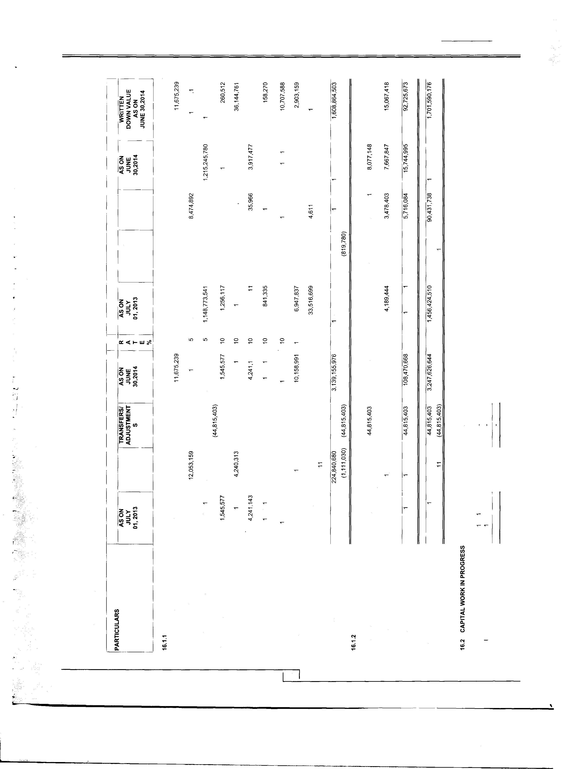
37

Kohinoor Spinning Mills Limited
Annual Report
2014

0 ..... 0
w "N' 0 co <D
"co'
N <D
"' "' "'
"L(')
"00'
0
"' "'
;::; ;1; ;;s

z=>
.,;
r-,
"N....'.
";:;:';· "o'i
".,'; <aD, co
(""')
<D <D <D
"0' 0
"N....'.·
<D
a:i
"<
co 0 "' ..... ;::;_ "' <D "' co "'
.,;
N
��>�wz
'°·
N"' "<D' N
".,'; "'
0
(")
«;
"N'
co 0
(") .,;
"r-.':
"N' "<D'
-zVl::,N.
13:ci:-,�
0
c
� "!
"' N ;:;:;_ "' "' <D

..... N � ..... ..... L() ..... "' N r-, "' "'
"' ;1; "N' "?.
"<D' ..... "!
0
"1 "N' "co' "'
0 "-e'- -e- ai �
Zw�
.,; (") <D <D ;;;
<D r-.: ';£
".,'; oi oi a:i
"..';
Ozo
00 ..... "' co 00
� 0 -e- "' "co' co N N
(I) ::::) N�
a:i ...... (")
r-.:
"<D'
L()
"<D'
.,;
0 -e-
..; 0 <D
N "'· "'·
N .,; N
0
co
<(-,�

z
0
0 "' "' "' "' "'
j::
w
<(
"' ;! "' "'
co 00
0
"' ..... 0 00 "' "'
"' N"'
0 :I:«
"....'. "'
"' "' N 0 "' N
"' "r-',
"co'.
w I- <(
r-.: <D N oi 0 a, <D a:i <D <D 0 ;;; ;::; a:i
« «w
co ..... "' N "'
�- "' io "' .....
D..
o>-
"a:'i
"..';
"("')
"' "..'; r-, 0 co
"....'.. <D
w u,
c
<D co "'
Vl co M
M in in
co
co N
N N
I- "N' N
"N'
N 00 co co
oi a":'i a,"
"a:'i oi oi ......
:::!: I- Vl
::,
-,
c
-c
N N N N N N L()
"' �"' "' "�' �"'
� �

-e- 00 N 00 "' "' ;::: 0 ..... N .... "' 0 ...
"' N "' ..... 0 "'
.i.o...
cr, ;;; co "' 0 ai

Z>�
a:i
N "r-.':
"("') ......
"! ...... 0
:;: ;::; 0
oi °co'·

a:i
"o'i
°'·
"' "'
"'·
co.

.....
0..J O
"' "N'
"! "! 00 co
"co'. 0
"' "0'
....... co
"<D'
'°·
Vl::, �
<( -,,..
a:i ..;
co
N
"' (")
"' "<D' "..';
oi N
;:::
0 "' o.
"' "'
"1 "1

O::<(t-W�
"' "' "' � � � � � 0 0 "' 0
"' ..... "' ..... N 0 ;;; ai N N 0
"'

.... ....
.....
....
"N'
<coD N ..... 00 "' "'
co cr,
co "' 0
"<D' "<D' "'
0 .,; a:i .,;
N N (")
".,',·
oo.
00
r-.: oi (") N
N N
...... 0
0
(")
N Zw�
.....
N ...
ai :;:
q ;::; co co
:;:
N co . ;;
....
O·zo
'°·
"...'. .... "'· <D N
cr, N
.....
V<l-::,, N..
"' .... "' 0
;: oi .,; N ..; a:i
"o'i .,; 0
"0'
;"::';· "N' N
:;

-1-
viz
<D ..... "' <D .... <D N

0 0 0 0 0 0 0 0 0 0 0 0
0 0 0 0 0 0 0 0 0 0 0 0
« w 0 co. 00
co 0 00
co '°· "":. .....
w:::.
....
;;; oi
"�'·
oi 0 oi ";;';·
oi ;;; :;: j
:,; I- Vl
.... q
;; 00
...'. "'
;; lO
"'.
z Vl
�3
q
a:i ::£ N
N
"a:'i ..; o. .... o. "'
(")
::::. � N� N �
.....
I-
Vl I- <(
0
0

;:;:; 0 N

(0 0 ..... 0 0 0 ..... 0
0 0 0 N
�
in�
"'·
N co
"co'
0 "0' 0 0 0 "' 0
�Q .....
"<D'· o. "o'i
.... N
(") r-.: ..;
N
r-.:
0 0 ..; ......
Et.i
co <D co "co'.
"' lO ..... lO .... .... ..... "'
C..J
cw
"' 0 N
N "'
.,; "'
.,;
.,;
<D "t:'c
<( e.
«; ..; .,;
"'
t:c
t:c 0
"' CD "0' ..... 0

...'.
0 c..o..
ai ;::; lO 0 "' "' 0
"! 00
"'·
a:i
" '
..... 0
lO 00
0
"r-.':
N "' co
0 <D <D 0
0 N N "<D'
Z>�
.l.O...
;:::
.,; ..; :;:
0 (") ..; (") 0 (") (")
N co 0 co N N
"0'
.... ....
0..JO
Cl)::::> N_
'°·
.",',·
.....
oi
"'· "N'.
...
o. l"O'.
"o'i ;':°;:;· ."..'..
N"'
N ..... 0
(") .,; 0
<( -,,..
0
CD ..... ..... N
"' "' co
"' ai
N N. N

0
z
<( .,
0 (f) z (f) .,
...J
(f) CD
...J z
(f) 0 w D..
0 >- I- i=
w
0::
>- ::,
I 0:: 0 z <( ::, 0:: q:
w ..,
Vl w w i= ...J (f) I- w
I- w
z ::i ::a: ...J I- x z ....
w 0::
:i:
...J
Cl. <( z G: :i: 0
Vl 0
u. (.) � 5
I- w
0 (.)
N..
Vl z <( a
(f) ::a:
z <( c
«
:3
(!)
0 (f) 0 ...J 0 z a
::i
0 (f) � w 5 "..' "..' "'.'>
Vl <(
z ::a: (f) w �
Cl. <( ::;; ::,
::,
z ...J (.? z ...J (.) z 0:: (f) ..
(f) Cl> .c.
j:: 0 <(
w Ct'. <( 0 w ::, w D..
<( w
D..
0 Q z s: :I: w I- ...J ::, " Q
0
0
...J ::,
j::
� w I ci I- I- (f) Cl. (.) z (.) q: w I- (.) q:
z w ...J
z w (.) ...J w Vl z
« w w
<( Cl w 0
...J G:
0::
:i:
:i:
.... !!
<( D.. 3:
0::
5 ...J ::, ...J 0 w u. ::, w
"0'
;:ti ::i w "' 0
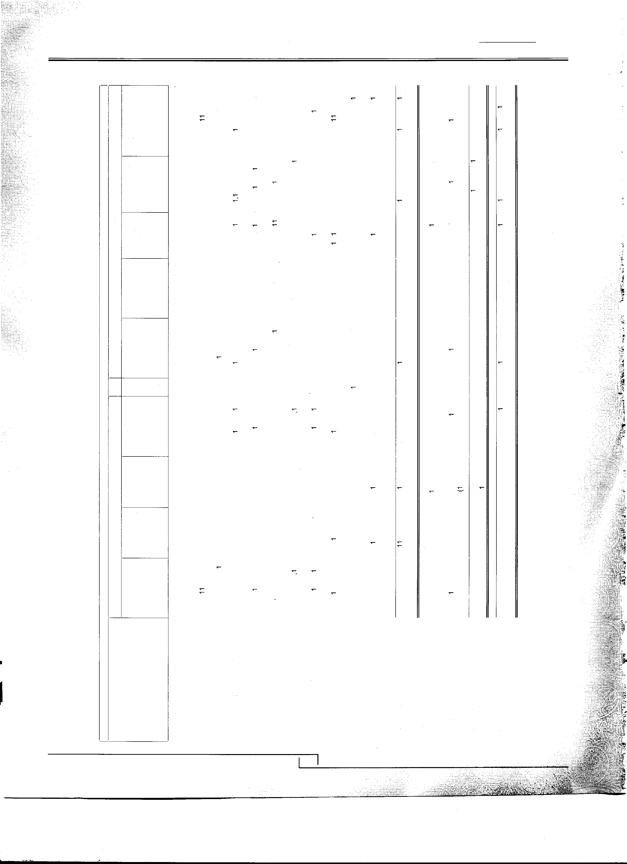D..
0 0 u. Cl Cl. I- w I- I- 0 u. > N ..J Cl. > N I-

38

Kohinoor Spinning Mills Limited

:;;
..
"' �
s: 0
o s:
Annual Report
2014
:i
c.
0
.e.
."..J'
::,
Cl'.)
""
:i ."c'
c "'
..:.: <(
D. :.
CT
s":'
�
ia 0) "' N
co
"' "' ,..__

c"'
., ...

a:,
CD
....
c. "'
M cc
..
CD ;;;
<Ji
c � ., r-: N. 0
.Q
N
<ii
s
..
0 c. cc "'
::,
s
,,
0 0,
:i; z
ia 0 ;;; r-, co
"' ",.._'
":
.. °'·
",.._' M
0 ('?
c.
c co
"' ;;;
a, ;;;
"'
N :
� CD
0 "'
c: 0
N ....
.,i 0
N ::, co
c: �
·;;;
C>
,",' 0
.. 0
0
e
.. ,.._ Ol
o ,..,._;
"' 0
D..
ia
(I)
z N N

0
"N'.
;;;
N

0
...:.,.
a,
;;;

c..
.c.:

...
o0
0
"q'
�

Qi
,::,
E c
c. ::,
,e.,.r

,"::',
:i (/)

Q)
c
0
c.. �.. <O t
0
:i a.
a.
'ii " "?
.. w Q) c
(/)
i.. t: w
Qi
"c' "Q')
.c a.
D. ...J Q) Q)
c.
e ..
Q)
(/) x
c. 0c ."c' Q)
...J c (/) >
ia :c ., ia
"' "' (/)
0 0 Q)
I
I :l3 ·;:; 0 ·1:
s..

� Q) 0 ,::,
.:,:, e? 1ii .E
"' a.
0 (..) <(

M ....
<�O <�O

39

Kohinoor Spinning Mills Limited
Annual Report
2014

 |  | Note | 2014  (Rupees) | 2013  (Rupees)
17 | LONG-TERM LOANS
 | Loans to Executives - Considered good | 17.1 | 16,190,190 | 14,609,464
 | Less: Current portion | 23 | (327,000) | (480,000)
 |  |  | 15,863,190 | 14,129,464

17.1 These represent long term loans made to executives as per policy of the Company against house building finance.
These are secured against the employees gratuity balances and are free of interest.

2014 2013
(Rupees) (Rupees)
18 | Aggregates maximum balance due at the end of any month during the year  LONG-TERM DEPOSITS | 16,007,187 | 14,129,464
 | Security Deposits
 | Utilities | 10,411,342 | 10,411,342
 | Others | 150,000 | 150,000
 |  | 10,561,342 | 10,561,342
19 | LONG-TERM INVESTMENT
 | Held as avaiable for sale
 | Other - Quoted
 | KASB Modaraba 166,320 modaraba certificates of Rupees 10 each. | 790,019 | 1,081,079
 |  | 790,019 | 1,081,079
20 | STORES AND SPARES
 | Stores | 44,597,836 | 80,971,612
 | Spares | 59,631,733 | 15,863,380
 |  | 104,229,569 | 96,834,992
21 | STOCK-IN-TRADE
 | Raw material | 1,331,618,90� | 1,233,765,610
 | Work-in-process | 125,987,330 | 131,924,270
 | Finished goods | 311,423,510 | 209,093,017
 | Waste | 3,629,471 | 6,954,203
 |  | 1,772,659,213 | 1,581,737,100
22 | TRADE DEBTS - Considered good
 | Foreign - Secured | 18,006,227 | 23,459,761
 | Local - Un-secured 22.1 | 361,242,637 | 298, 148,421
 |  | 379,248,864 | 321,608,182

-

�

40

Kohinoor Spinning Mills Limited
Annual Report
2014

22.1 This includes balances receivable from the following associated undertakings : -

2014 2013
(Rupees) (Rupees)

- 26
 |  | Chakwal Spinning Mills Limited | 1,356,933 | 1,422,363
 |  | Yousaf Weaving Mills Limited | 6,358,842 | 5,242,426
 |  | Khawaja Mohammad Jawed (Pvt) Ltd |  | 2,719,000
 |  |  | 7,715,775 | 9,383,789
 | 23 | LOANS AND ADVANCES
 |  | Current portion of loans to executives | 327,000 | 480,000
 |  | Advances - considered good
 |  | Suppliers | 31,439,725 | 28,283,446
 |  | Service providers | 1,001,408 | 1,054,990
 |  | Others | 210,535 | 543,601
 |  | Staff - interest free | 26,932,802 | 23,153,963
 |  | Letters of credit | 712,109 | 1,686,829
 |  |  | 60,623,579 | 55,202,829
 | 24 | TRADE DEPOSITS,PRE·PAYMENTS AND OTHER RECEIVABLES
 |  | Deposits
f� |  | Margin with banks | 18,510, 191 | 27,983,911
 |  | Pre-payments - insurance | 1,249,546
 |  | Other receivables - considered good
:r.,
i:, |  | Sales tax receivable  IESCO | 27,039,853 | 22,428,840  11,665,346
 |  |  | 46,799,590 | 62,078,097
 | 25 | CASH AND BANK BALANCES
 |  | Cash in hand | 1,127,050 | 411,067
 |  | In current accounts | 9,669,098 | 8,851,198
 |  | In saving accounts | 113,934 | 322,500
 |  |  | 10,910,082 | 9,584,765
 |  | SALES-NET
 |  | Local | 4,225,006,665 | 3,626,223, 734
 |  | Export | 2,597,987,051 | 2,603,896, 764
�-i |  |  | 6,822,993,716 | 6,230, 120,498

41

Kohinoor Spinning Mills Limited
Annual Report
2014

 |  | Note | 2014 (Rupees) | 2013 (Rupees)
27 | COST OF SALES
 | Raw material consumed | 27.1 | 4,444,333,027 | 4, 175,320,650
 | Salaries, wages and benefits | 27.2 | 465,595,500 | 434,974,078
 | Fuel and power |  | 845,528,081 | 531,973,464
 | Insurance |  | 26,389,524 | 20,173,142
 | Packing material |  | 137,993,480 | 120,789,757
 | Repairs and maintenance |  | 11,763,674 | 4,226,965
 | Stores and spares consumed |  | 109,981,017 | 72,253,712
 | Vehicles running and maintenance |  | 7,154,048 | 6,202,213
 | Communication |  | 1,287,716 | 1,943,210
 | Travelling and conveyance |  | 2,832,298 | 1,979, 138
 | Doubling charges |  | 6,800,000 | 2,480,000
 | Miscellaneous |  | 22,779,789 | 23,336,725
 | Depreciation | 16 | 86, 191,981 | 87,846,359
 |  |  | 6, 168,630, 135 | 5,483,499,413
 | Work-in-process
 | Opening |  | 131,924,270 | 88,960,294
 | Closing |  | (125,987 ,330) | (131,924,270)
 | Cost of goods manufactured |  | 6,174,567,075 | 5,440,535,437
 | Finished goods and waste
 | Opening stock |  | 216,047,220 | 158,934,530
 | Closing stock |  | (315,052,981) | (216,047,220)
 |  |  | 6,075,561,314 | 5,383,422,747

27.1 RAW MATERIAL CONSUMED
Opening stock | 1,233,765,610 | 858,083,277
Purchases | 4,558, 108,855 | 4,575,442,467
 | 5,791,874,465 | 5,433,525,744
Cost of raw material sold | (15,922,536) | (24,439,484)
 | 5, 775,951,929 | 5,409,086,260
Closing stock | (1,331,618,902) | (1,233,765,610)
 | 4,444,333,027 | 4, 175,320,650
27.2 It includes Rs.23,223,783 (2013: Rs. 17,203,004) in respect of gratuity.

-

42

Kohinoor Spinning Mills Limited

29.1 It inculdes Rs.8,888,641 (2013 : Rs. 6, 176,859) in respect of gratuity

29.2 None of the directors or their spouses had any interest in any of the donees.
Annual Report
2014
 |  | Note | 2014 (Rupees) | 2013 (Rupees)
28 | DISTRIBUTION COST
 | Comission to selling agents |  | 74,083,237 | 54,060,699
 | Ocean freight |  | 18,770,094 | 25,778,533
 | Local freight |  | 39,976,260 | 39,474,959
 | Clearing & forwarding |  | 7, 149,273 | 6,922,936
 | Export development surcharge |  | 5,408,453 | 5,474,268
 | Others |  | 6,755,088 | 3,674,277
 |  |  | 152,142,405 | 135,385,672
29 | ADMINISTRATIVE EXPENSES
 | Salaries and benefits | 29.1 | 61, 186,652 | 55,360,230
 | Travelling and conveyance |  | 2,666,667 | 3,276,404
 | Rent, rates and taxes |  | 2,400,818 | 1,939,661
 | Printing and stationery |  | 798,442 | 1, 193,652
 | Communication |  | 4,373,576 | 4,753,891
 | Entertainment |  | 3,318,081 | 3,931,227
 | Electricity and gas |  | 6, 124,821 | 5,163,394
 | Vehicles running and maintenance |  | 12,556,655 | 10,654,882
 | Fee and subscription |  | 1,834,651 | 3,465,877
 | Legal and professional |  | 199,200 | 383,100
 | Repairs and maintenance |  | 10,478,997 | 13,457,538
 | Donations | 29.2 | 5,057,113 | 2,855,725
 | Miscellaneous |  | 7,736,539 | 5,645,009
 | Sales tax paid | 29.3 |  | 22,663,650
 | Depreciation | 16 | 4,239,757 | 2,831,763
 |  |  | 122,971,969 | 137,576,003

29.3 This represents payment made by the Company in the year 2013 under SRO 179(1)/2013. This SRO was issued by Fedral Board of Reveneue for Sales Tax Amnesty Scheme. The purpose of this scheme was to facilitate textile sector in clearing past sales tax liabilities. The Company made this payment under protest and in compliance with general consensus of textile sector.

30 | FINANCE COST  Interest I mark-up on:
 | Long-term loan |  | 3,810,008 | 9,554,489
 | Finance leases |  | 7,904,999 | 5,074,782
 | Short-term borrowings |  | 197,818,072 | 181,895,248
 | Workers profit participation fund |  | 9,920,904 | 7,537,214
 | Inland letters of credit |  | 6,435,547 | 10,603,852
 | Bank charges and commission |  | 33,925,284 | 23,823,664
 |  |  | 259,814,814 | 238,489,249
 |  | 43

Kohinoor Spinning Mills Limited

31 OTHER OPERATING EXPENSES
Annual Report
2014

2014 2013
Note (Rupees) (Rupees)
Auditors' remuneration 31.1 800,000 800,000
Exchange loss 10,438, 180 11,323, 117
Workers' profit participation fund 9,956,979 16,299,686
Loss on sales of raw material 2,417,195
23,612,354 28,422,803

31.1 Auditors' remuneration

Statutory audit | 700,000 | 700,000
Half yearly review and review of code of corporate governance | 100,000 | 100,000
 | 800,000 | 800,000
32 OTHER OPERATING INCOME

Gain on sale of fixed assets 283,750 2,670,501
Profit on sales of raw material 199,516
Gain from trading activity 8,000
291,750 2,870,017

33 TAXATION

Opening balance 4,696,724 3,563,648

For the year 33.1 68,229,937 44,170,086
Less: Paid/ adjusted (61,613,286) (43,037,009)

11,313,375 4,696,724

33.1 This represents liability provided under Section 113 and 154 of the Income Tax Ordinance, 2001 on the basis of gross turnover from all sources.

33.2 The income tax assessment of the company has been finalized upto and including tax year 2013 by the deeming provisions of Income Tax Ordinance 2001, however appeals before different appellate forums are pending on various legal issues.

33.3 No numeric tax rate reconciliation is presented in these financial statements as the Company is liable to pay minimum tax under Section 113 and under Section 154 of the Income Tax Ordinance 2001.

33.4 Deferred tax asset amounting to Rs.989 million reduced due to brought forward losses amounting Rs. 735 million has not been recoginized in the current year, as the attributeable temporary differences are not expected to reverse in the forseeable future.

34 | EARNINGS PER SHARE - Basic
 | Profit after taxation | 120,952,672 | 265,523,955
 | Weighted average number of ordinary shares | 130,000,000 | 130,000,000
 | Earning per share - Basic | 0.93 | 2.04
 | 34.1 Diluted earning per share

There is no dilution effect on the basic earning per share of the Compnay as the company has no such commitments.

44

Kohinoor Spinning Mills Limited
Annual Report
2014

 |  | 2014  (Rupees) | 2013  (Rupees)
35 | CASH FLOW FROM OPERATING ACTIVITIES
 | Profit before taxation | 189,182,609 | 309,694,041
 | Adjustments of non cash charges and other items
 | Depreciation/amortization | 90,431,738 | 90,678,122
 | Gratutiy | 32, 112,424 | 23,379,863
 | Workers Profit Participation Fund | 9,956,979 | 16,299,686
 | Gain on sales of fixed assests | (283,750) | (2,670,501)
 | Dividend paid | (4,810,693) | (815,409)
 | Finance cost | 259,814,814 | 238,489,249
 | Operating profit before working capital changes | 576,404,122 | 675,055,051
 | (lncrease)/decrease in current assets
 | Stores and spares | (7,394,577) | (45,188,236)
 | Stock-in-trade | (190,922,113) | (475,759,029)
 | Trade debts | (57,640,682) | (173,985,284)
 | Loans and advances | (5,573,750) | (5,410,430)
 | Trade deposits, prepayments & other receivables | 15,278,507 | (20,973,262)
 |  | (246,252,615) | (721,316,241)
 | Increase in current liabilities
 | Trade and other payables | 48,299,863 | 167,238,885
 |  | 378,451,371 | 120,977,695

45

Kohinoor Spinning Mills Limited

36 REMUNERATION OF CHIEF EXECUTIVE, DIRECTORS AND EXECUTIVES
Annual Report
2014

2014 2013 (Rupees) (Rupees)

EX CHIEF

E DIRECTORS
I
I

EXECUTIVES
ECUTIV |  | EXECUTIVE DIRECTORS
Remuneration | 4,000,000 | 6,761,300 | 11,553,080 | 4,000,000 | 7,296,000 | 8,800,440
House Rent | 1,800,000 | 3,042,000 | 5,198,886 | 1,800,000 | 3,283,200 | 3,960,198
Medical | 562,565 | 3,428,362 | 1,020,463 | 834,779 | 1,290,742 | 926,163
Gratuity |  |  | 1,672,075 |  |  | 1,015,055
Utilities | 200,000 | 336,700 | 577,654 | 200,000 | 364,800 | 440,022
 | 6,562,565 | 13,568,362 | 20,022,158 | 6,834,779 | 12,234,742 | 15,141,878
Number of persons |  | 3 | 12 | 1 | 3 | 7

CHIEF I I EXECUTIVES

The Chief Executive, Directors and certain Executives were provided with company maintained cars.

36.1 No fee has been charged by the directors for attending the Board Meetings.
36.2 Executives are defined as employees with basic salary exceeding Rs.500,000.
36.3 Chief Executive, Director and executives are provided with company maintained cars in addition to above.

37 TRANSACTIONS WITH RELATED PARTIES

37 .1 Transactions with related parties comprise associated undertakings and other related parties through directorship and close family members of the directors of the company.

Transactions with related parties undertaken during the year were as follows:•

Purchases of raw materials and finished goods
(Chakwal Textile Mills Limited) (Yousaf Weaving Mills Limited)

10,355, 113
2,922,400
13,277,513

Sales of raw materials and finished goods

(Yousaf Weaving Mills Limited) (Chakwal Spinning Mills Limited) (Chakwal Textile Mills Limited)

Aggregate maximum balance due at the end of any month during the year.

38 FINANCIAL RISK MANAGEMENT

13,326,022
2,674,440

16,000,462

9,786,484

39,669,611

12,583,755

52,253,366

12,545,337
38.1 The Company has exposures to the following risks from its use of financial instruments: Market Risk
Credit Risk
Liquidity Risk

The Board of Directors has overall responsibility for the establishment and oversight of the Company's risk management framework. The Board is also responsible for developing and monitoring the Company's risk management policies.
-

a) Market Risk

i) Currency Risk

Currency risk is the risk that the fair value of future cash flows of a financial instrument will fluctuate because of changes in foreign exchange rates. Currency risk arises mainly from future commercial transactions or receivables and payables that exist due to transactions in foreign currencies.

Kohinoor Spinning Mills Limited
Annual Report
2014

The Company is exposed to currency risk arising from various currency exposures. Primarily with respect to the United States Dollar (USO). Currently, the Company's foreign exchange risk exposure is restricted to the amounts receivable from I payable to foreign entities. The Company's exposure to currency risk was as follows:
2014 2013
Rupees in thousand

Trade debts-USO | 18,006 | 23,460
Supplier's credit-EURO | 256,476 | 147,793
The following significant exchange rates were applied during the year.
Average rate (Rupees per US Dollar) | 98.58 | 95.78
Reporting date rate (Rupees per US Dollar) | 98.75 | 98.40
Average rate (Rupees per US Euro) | 131.66 | 124.95
Reporting date rate (Rupees per Euro) | 134.73 | 128.58

Foreign Exchange Risk Management

Foreign currency risk arises mainly where receivables and payables exist due to transactions with foreign undertakings and balances held in foreign currency. However the company is not materially exposed to foreign currency risk on assets and liabilities. As at June 30, 2014 financial assets include Rs.18.006 million (2013: Rs.23.460 million) and financial liabilities include Rs. 256.476 million (2013: Rs. 147.793 million) which are subject to foreign currency risk against US Dollars and Euro respectively.

Foreign Currency Sensitivity Analysis

At June 30, 2014 if the Rupee had weakened I strengthened by 5% against the US Dollar and Euro with all other variables held constant, profit for the year would have been lower I higher by Rs. 11.924 million (2013: Rs. 6.217 million) mainly as a result of foreign exchange gains I losses on transaction of foreign currency trade debts and US Dollar and Euro denominated borrowings.

ii) Other Price Risk

Other price risk represents the risk that the fair value or future cash flows of a financial instrument will fluctuate because of changes in marker prices (other than those arising from interest rate risk or currency risk), whether those changes are caused by factors specific to the individual financial instrument or its issuer, or factors affecting all similar financial instrument traded in the market. The Company is not exposed to equity and commodity price risk.

Sensitivity analysis

iii)
Interest Rate Risk
This represents the risk that the fair value or future cash flows of a financial instrument will fluctuate because of changes in market interest rates.

The Company has no significant long--term interest-bearing assets. The Company's interest rate risk arises from long term financing, lease liabilities and short term borrowings. As the borrowings are obtained at variable rates, these expose the Company to cash flow interest rate risk.

At the balance sheet date the interest rate profile of the Company's interest bearing financial instruments was:

 | 2014 (Rupees) | 2013 (Rupees)
Floating rate instruments
Financial Liabilities
Long term financing |  | 7,142,852
Liabilities against assets subject to finance lease | 36,792,879 | 27,885,024
Short term borrowings | 1,572,235,844 | 1,498,847, 142
Financial Assets
Bank Balances - Saving Accounts | 113,934 | 322,500

Cash flow sensitivity analysis for variable rate instruments

A change of 100 basis points in interest rates at the reporting date would have Increased I (decreased) equity and profit or loss by Rs. 15.72 million (2013: Rs. 14.98). This analysis assumes that all other variables, in particular foreign currency rates, remain constant. The analysis is performed on the same basis as for 2013.

47

Kohinoor Spinning Mills Limited

b) Credit Risk
Annual Report
2014
Credit risk represents the risk that one party to a financial instrument will cause a financial loss for the other party by failing to discharge an obligation. Carrying amounts of financial assets represent the maximum credit exposure. The maximum exposure to credit risk at the reporting date was as follows:-
2014 2013
(Rupees) (Rupees)

Long term loans | 15,863, 190 | 14, 129,464
Long term deposits | 10,561,342 | 10,561,342
Trade debts | 379,248,864 | 321,608, 182
Advances, trade deposits and other receivables | 60,623,579 | 55,202,829
Cash and bank balances | 10,910,082 | 9,584,765

The credit risk on liquid funds (cash and bank balances) is limited because the counter parties are banks with a reasonably high credit rating. The names and credit rating of major banks where the Company maintains its bank balances are as follows.

Name of Bank | Rating Agency | Short-term | Credit Rating | Long-term
Askari Bank Limited  MCB Bank Limited | PAC RA PAC RA | A1+ A1+ |  | AA  AAA
National Bank of Pakistan Limited | PAC RA | A-1+ |  | AAA
Habib Metro Bank | PAC RA | A1+ |  | AA+
Meezan Bank Limited | JCR-VIS | A-1+ |  | AA
Allied Bank Limited | PAC RA | A1+ |  | AA+
Standard Chartered Bank (Pakistan) Limited | PAC RA | A1+ |  | AAA
c) Liquidity Risk

Liquidity risk is the risk that an entity will encounter difficulty in meeting obligations associated with financial liabilities. The Company manages liquidity risk by maintaining sufficient cash and the availability of funding through an adequate amount of committed credit facilities. As at the balance sheet date, the Company had Rs. 1,593 million worth short term borrowing limits available from financial institutions and Rs. 10.91 million cash and bank balances. Following are the contractual maturities of financial liabilities, including interest payments.

Contractual maturities of financial liabilities as at June 30, 2014:

 | Carrying  Amount | Contractual cash flows | Less then  1 year | Between  1 to 5 years | 5 years and above
 | Rupees | Rupees | Rupees | Rupees | Rupees
Supplier's credit | 256,4 76,463 | 256,476,463 | 137,112,859 | 119,363,604
Liabilities against leased assets | 70,263,677 | 84,489,339 | 42,435,569 | 42,053,770
Trade and other payables | 469,415,415 | 469,415,415 | 469,415,415
Accrued interest | 50,828,993 | 50,828,993 | 50,828,993
Short term finances | 1,572,235,844 | 1,762,902,972 | 1,762,902,972
Contractual maturities of financial liabilities as at June 30, 2013:
 | ·Carrying Amount Rupees | Contractual cash flows Rupees | Less then  1 year  Rupees | Between  1 to 5 years  Rupees | 5 years and above Rupees
Supplier's credit | 147,793,179 | 147,793,179 | 74,711,260 | 73,081,919
Long-term finances | 50,000,000 | 55,515,000 | 42,857,148 | 12,657,852
Liabilities against leased assets | 47,052,372 | 56,003,021 | 24,855,900 | 31,147,121
Trade and other payables | 409,871,048 | 409,871,048 | 409,871,048
Accrued interest | 47,972,996 | 47,972,996 | 47,972,996
Short term finances | 1,498,847, 142 | 1,671,664,217 | 1,671,664,217

-
i

The contractual cash flows relating to the above financial liabilities have been determined on the basis of interest rates I mark up rates effective as at 30 June. The rates of interest mark up have been disclosed in respective notes to these financial statements.

48

Kohinoor Spinning Mills Limited
Annual Report
2014

38.2 Fair values of financial assets and liabilities

The carrying values of all financial assets and liabilities reflected in financial statements approximate their fair values. Fair value is determined on the basis of objective evidence at each reporting date.

38.3 Capital Risk Management

The Company's prime objective when managing capital to safeguards its ability to continue as a going concern in order to provide adequate returns for shareholders and benefits for other stakeholders and to maintain an optimal structure to reduce the cost f capital.

In order to maintain or adjust the capital structure, the company may adjust the amount of dividends paid to shareholders, issue new shares or sell assets to reduce debt.

Consistent with others in the industry, the company monitors capital on the basis of the gearing ratio. The ratio is calculated as total borrowings divided by total capital employed. Total borrowing comprises of long term loan, lease liabilities and short term borrowings (excluding short term borrowing from directors). Total capital employed is calculated as total
borrowings plus equity as on balance sheet date.
2014 (Rupees)
2013 (Rupees)

 | Total Borrowings | 1,913,261,694 | 1,743,692,693
 | Total Equity | 1, 138,020,366 | 1,027,513,397
 | Total capital employed | 3,051,282,060 | 2,771,206,090
 | Gearing Ratio | 62.70% | 62.92%
39 | PLANT CAPACITY AND PRODUCTION
 | Number of spindles installed | 79,944 | 78,984
 | Installed capacity in 20's count based on triple shift for 365 (2013 - 365) days (kgs) -Approximately | 35,984,727 | 35,552,608
 | Actual production after conversion into 20's count (kgs) | 28,956,019 | 27,926,635

The conversion into 20's count depicts the approximate efficiency as it fluctuates with changes in count of yarn spun and count mix in a particular period.

Under utilization of available capacity was due to normal maintenance and power shortage in shifting of counts.

40 NUMBER OF EMPLOYEES

The total number of permanent employees

2014

2644

2013

2813

41 DATE OF AUTHORIZATION OF ISSUE

These financial statements were authorized for issue on October 10, 2014 by the Board of Directors of the Company.

42 GENERAL

Figures have been rounded off to the nearest rupees.

43 SUBSEQUENT EVENT

43.1 The Board of Directors have proposed dividend of Re. 0.25 per shares as final dividend for the year ended June 30, 2014.
This is in addition to an interim dividend of Re. 0.5 per share already approved by the Board of Directors and paid to the shareholders. However the Directors have foregone their right to receive the dividend.

43.2 Post Balance Sheet Event

The shareholders, have decided to increase in authorized capital from Rs. 650,000,000 to Rs. 1,500,000,000 in their extra ordinary general meeting held on September 10, 2014. Consequently the paid up capital of the company is proposed to be raised from Rs. 650 million to Rs. 950 million. These share will be issued to the directors against their loan without indulging in the exercise of right issues to the existing members in accordance with the provision section 86(1) of the Companies Ordinance, 1984 subject to the approval of SECP. Such shares will rank pari passue with existing shares of the company. The legal formalities for increase in authorized capital and paid up capital are in process.

1·,·1 ••
"':: };!l:1i�r;

Lahore
October 10, 2014

(Mr. Mohammad Naveed)
Chief Executive

(Khawaja Mohammad Jahangir)
Director

1 49
- '.t.•_t: _!.i:__l: ;;;[_L.i�tl[l.rJ_\.;,·
. (;./::: ,:;;{..,�:..,\.. ·.. :-__·,.·- .·-...._�;._,:,:..·.·,··.-.:;.-.J. �::..,·.�t,,:..·;'.- . :C"::t::;.-:';::;(• :i::;�:-;;::: --

Kohinoor Spinning Mills Limited
Annual Report
2014

1. Incorporation Number

2. Name of the Company
THE COMPANIES ORDINANCE 1984 (Section 236(1) and 464)
PATTERN OF SHAREHOLDING

I L-01895

I KOHINOOR SPINNING MILLS LIMITED

FORM 34

3. Pattern of holding of the shares held by the shareholders as at
4. No. of Shareholders | From | ------Shareholding------  To | Total Shares Held
62 |  | 100 | 1,917
56 | 101 | 500 | 22,315
44 | 501 | 1,000 | 40,883
77 | 1,001 | 5,000 | 210,048
26 | 5,001 | 10,000 | 198,751
3 | 10,001 | 15,000 | 39,009
4 | 15,001 | 20,000 | 71,500
2 | 20,001 | 25,000 | 47,000
 | 25,001 | 30,000 | 30,000
 | 30,001 | 35,000 | 35,000
 | 35,001 | 40,000 | 40,000
3 | 40,001 | 45,000 | 124,600
3 | 45,001 | 50,000 | 150,000
 | 50,001 | 55,000 | 53,100
1 | 55,001 | 60,000 | 55,067
2 | 70,001 | 75,000 | 146,500
 | 80,001 | 85,000 | 85,000
2 | 85,001 | 90,000 | 175,500
 | 100,001 | 105,000 | 101,500
 | 105,001 | 110,000 | 110,000
12 | 110,001 | 115,000 | 1,350,000
 | 135,001 | 140,000 | 140,000
 | 145,001 | 150,000 | 150,000
 | 420,001 | 425,000 | 423,500
 | 445,001 | 450,000 | 447,500
 | 490,001 | 495,000 | 495,000
 | 600,001 | 605,000 | 602,327
 | 4,205,001 | 4,210,000 | 4,205,250
 | 6, 180,001 | 6,185,000 | 6,181,500
 | 17,485,001 | 17,490,000 | 17,489,500
 | 19,960,001 | 19,965,000 | 19,960,250
 | 20,000,001 | 20,005,000 | 20,004,500
 | 28, 110,001 | 28, 115,000 | 28,111,000
 | 28,700,001 | 28,705,000 | 28,701,983
317 |  |  | 130,000,000

30-06-2014

-

50

Kohinoor Spinning Mills Limited
Annual Report
2014

5. Categories of shareholders

5.1 Directors, Chief Executive Officers, and their spouse and minor childern
Share held

105,308,054
Percentage

81.0062
5.2 Associated Companies, | 0
undertakings and related
parties.  5.3 NIT and ICP | 100 | 0.0001
5.4 Banks Development | 11,225 | 0.0086
Financial Institutions, Non
Banking Financial Institutions.

5.5 | Insurance Companies | 53, 100 | 0.0408
5.6 | Modarabas and Mutual  Funds | 699,327 | 0.5379
5. 7 | Share holders holding 10% | 114,699,304 | 88.2302
 | or more
5.8 | General Public
 | a. Local | 23,667,395 | 18.2057
 | b. Foreign
5.9 | Others (to be specified)
 | 1. Joint Stock Companies | 187,800 | 0.1445
 | 2. Foreign Companies | 16,000 | 0.0123
 | 3. Pension Funds | 55,067 | 0.0424
 | 4. Others | 1,932 | 0.0015

-
6. | Signature of  Company Secretary | Company Secretary
7. | Name of Signatory
8. | Designation
9. | NIC Number
10. | Date | 30 | 06 | 2014

51

Kohinoor Spinning Mills Limited
Annual Report
2014

Catagories of Shareholding required under Code of Coprorate Governance (CCG) As on June 30, 2014

/sr. No. Name No. of Shares
Held

Percentage

Associated Companies, Undertakings and Related Parties (Name Wise Detail):

Mutual Funds (Name Wise Detail)
1 | GOLDEN ARROW SELECTED STOCK FUND | 500 | 0.0004
2 | PRUDENTIAL STOCK FUND LTD. (CDC) | 6,000 | 0.0046
3 | PRUDENTIAL STOCK FUND LTD. (03360) (CDC) | 50,000 | 0.0385
4 | CDC TRUSTEE NATIONAL INVESTMENT (UNIT) TRUST (CDC) | 602,327 | 0.4633
Directors an  1 | d their Spouse and Minor Children (Name Wise Detail): KHAWAJA MOHAMMAD JAVED | 20,383,750 | 15.6798
2 | KHAWAJA MOHAMMAD JAHANGIR PHINO | 6,181,500 | 4.7550
3 | KHAWAJA MOHAMMAD TANVEER | 4,205,250 | 3.2348
4 | KHAWAJA MOHAMMAD KALEEM | 28,710,554 | 22.0850
5 | KHAWAJA MOHAMMAD NADEEM | 17,489,500 | 13.4535
6 | KHAWAJA MOHAMMAD NAVEED | 28,111,000 | 21.6238
7 | MR. MOHAMMAD HAMZA YOUSAF | 1,500 | 0.0012
8 | MRS. NUSRAT ARFEEN W/0 KHAWAJA MOHAMMAD TANVEER | 112,500 | 0.0865
9 | MRS. ANDLEEB KHANUM W/0 KHAWAJA MOHAMMAD NADEEM | 112,500 | 0.0865
Executives:

Public Sector Companies & Corporations:

Banks, Development Finance Institutions, Non Banking Finance
Companies, Insurance Companies, Takaful, Modarabas and Pension Funds:
159,892 0.1230
Shareholders holding five percent or more voting intrest in the listed company (Name Wise Detail)

S. No. | NAME | Holding | %Age
1 | KHAWAJA MOHAMMAD JAVED | 20,383,750 | 15.6798
2 | KHAWAJA MOHAMMAD KALEEM | 28,710,554 | 22.0850
3 | KHAWAJA MOHAMMAD NADEEM | 17,489,500 | 13.4535
4 | KHAWAJA MOHAMMAD NAVEED | 28,111,000 | 21.6238
5 | MR. NADEEM BASHIR (CDC) | 20,004,500 | 15.3881

All trades in the shares of the listed company, carried out by its Directors, Executives and their spouses and minor children shall also be disclosed:
S. No. | NAME | SALE | PURCHASE
1 | KHAWAJA MOHAMMAD KALEEM | 9,700,000 | 337,500
2 | KHAWAJA MOHAMMAD NAVEED | 10,000,000

-

52

Kohinoor Spinning Mills Limited

Form of Proxy - 42nd Annual General Meeting
·,

The Corporate Secretary
Kohinoor Spinning Mills Limited
7/1 E-3 Main Boulevard Gui berg III, Lahore
Annual Report
2014

Folio# I
CDC A/C #.

Participant
I.D Account#
Shares held

r I/We of _

being a member (s) of KOHINOOR SPINNING MILLS LIMITED hold ordinary shares hereby appoint Mr./Mrs./Miss of or failing him/her _ of as my /our
Proxy to attend and vote for me/us and on my/our behalf at the 42nd Annual General Meeting of the Company to be held on Friday, 31st October, 2014 at 11 :00 a.m. at 31-F Main Market Gulberg II, Lahore and at every adjournment thereof.

Signed this day of 2014.

1. Witness: Signature: Name: Address: CNIC:

r- 2. Witness: Signature: Name:

Address: CNIC:

IMPORTANT

AFFIX REVENUE
STAMP OF FIVE RUPEES

Signature: ---------- (Signature appended above should agree
with the specimen signatures registered with the Company.)
1. This Form of proxy, duly completed and signed, must be received at the registered office of the company, at
7/1 E-3 Main Boulevard Gulberg III, Lahore Pakistan, not less then 48 hours before the time of holding the meeting.

2. If a member appoints more than one proxy and more than one instruments of proxy are deposited by a member with the company, all such instruments of proxy shall be rendered invalid.

53

